FORM No. SDDIET-FRM-32B Roll No. :2205405
SDDIET | SWAMI DEVI DYAL INSTITUTE OF ENGG. & TECHNOLOGY, BARWALA, PANCHKULA |  |  | LABORATORY MANUAL
SDDIET | PRACTICAL EXPERIMENT INSTRUCTION SHEET
SDDIET | PROGRAM TITLE: Create a Subroutine with arguments Passing & call the subroutine for specific number of times.
EXPERIMENT NO.: - 1 |  | DEPTT. :- I.T. | ISSUE DATE: -
LABORATORY:- SSP LAB |  |  | SEMESTER: -7th |  | PAGE.NO: 1

<% @ language=vbscript %>
<html>
<head>
</head>
<body >
<title>Program No.-1</title>
<h1><center><u>Program 1</u></center></h1>
<center>
<%
dim count
sub func(count)
response.write("<br>
<font size=4>My First ASP Page")
response.write("<br>Counter Value = ")
response.write(count)
response.write("<br>")
response.write("<br>")
response.write("<br>")
response.write("<br>")
response.write("</font>")
end sub
for count=0 to 3
func(count)
next
%>
</center>
</body>
</html>

PREPARED BY :- Ashish Verma | APPROVED BY :- Er. Kanika Gupta
FORM No. SDDIET-FRM-32B Roll No. :2205405
SDDIET | SWAMI DEVI DYAL INSTITUTE OF ENGG. & TECHNOLOGY, BARWALA, PANCHKULA |  |  | LABORATORY MANUAL
SDDIET | PRACTICAL EXPERIMENT INSTRUCTION SHEET
SDDIET | PROGRAM TITLE: Output
EXPERIMENT NO.: - 1 |  | DEPTT. :- I.T. | ISSUE DATE: -
LABORATORY:- SSP LAB |  |  | SEMESTER: -7th |  | PAGE.NO: 2

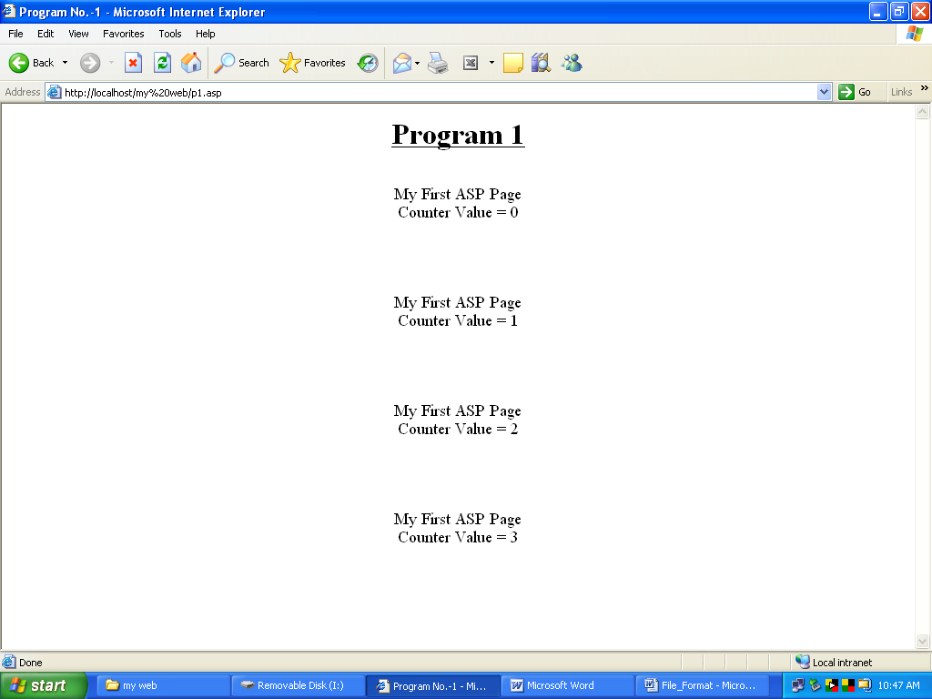

PREPARED BY :- Ashish Verma | APPROVED BY :- Er. Kanika Gupta
FORM No. SDDIET-FRM-32B Roll No. :2205405
SDDIET | SWAMI DEVI DYAL INSTITUTE OF ENGG. & TECHNOLOGY, BARWALA, PANCHKULA |  |  | LABORATORY MANUAL
SDDIET | PRACTICAL EXPERIMENT INSTRUCTION SHEET
SDDIET | PROGRAM TITLE: Write a program to display present day, month and date
EXPERIMENT NO.: - 2 |  | DEPTT. :- I.T. | ISSUE DATE: -
LABORATORY:- SSP LAB |  |  | SEMESTER: -7th |  | PAGE.NO: 3

<%@ language=vbscript%>
<html>
<head>
<title>Program no-2</title>
</head>
<body>
<h1><center><u>Program no-2</u></center></h1>
<center> <br>
<%
dim h
h=hour(now())
Response.write("<font size=4>Current time is: ")
Response.write(time())
If h<=11 then
response.write("<br><br><font size=5>Good Morning</font>")
elseif h<=15 then
response.write("<br><br><font size=5>Good Afternoon</font>")
else
response.wirte("<br><br><font size=5>Good Evening</font>")
end if
Response.write("<br><br><font size=4>Today’s date is: ")
Response.write(date())
Response.write("<br>")
Response.write("<br>Current year is: " )
Response.write(year(date))
Response.write("<br>")
Response.write("<br>Current month is: ")
Response.write(monthname(month(date)))
Response.write("<br>")
Response.write("<br>Today’s date is: ")
Response.write(day(date))

Response.write("<br>")
Response.write("<br>Today’s day is: ")
Response.write(weekdayname(weekday(date)))
%>
</center>
</body>
</html>

PREPARED BY :- Ashish Verma | APPROVED BY :- Er. Kanika Gupta

FORM No. SDDIET-FRM-32B Roll No. :2205405
SDDIET | SWAMI DEVI DYAL INSTITUTE OF ENGG. & TECHNOLOGY, BARWALA, PANCHKULA |  |  | LABORATORY MANUAL
SDDIET | PRACTICAL EXPERIMENT INSTRUCTION SHEET
SDDIET | PROGRAM TITLE: Output
EXPERIMENT NO.: - 2 |  | DEPTT. :- I.T. | ISSUE DATE: -
LABORATORY:- SSP LAB |  |  | SEMESTER: -7th |  | PAGE.NO: 4

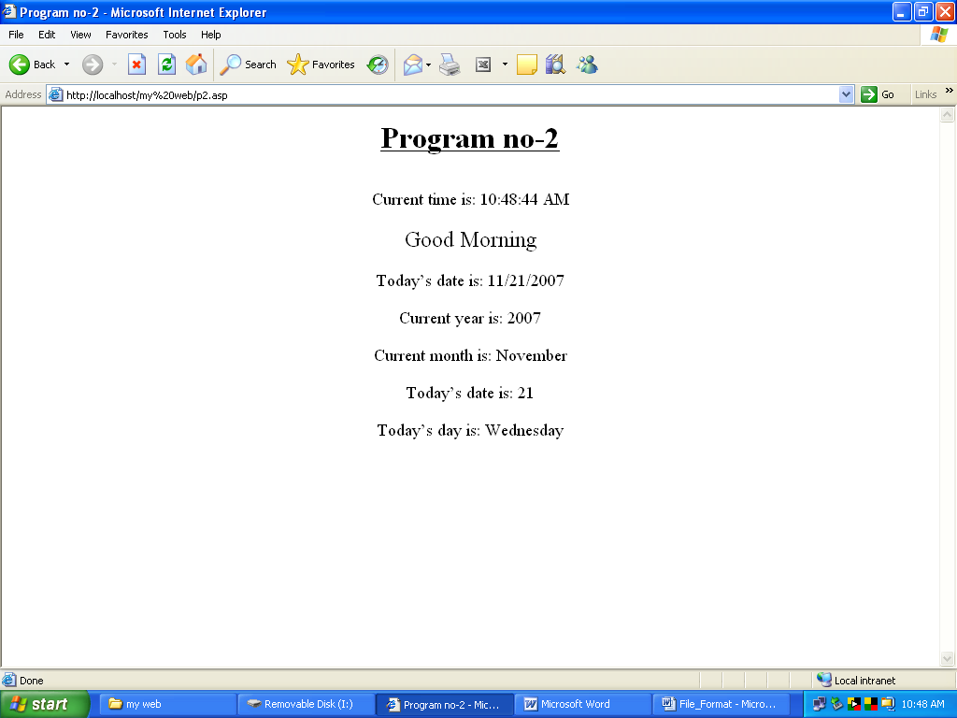

PREPARED BY :- Ashish Verma | APPROVED BY :- Er. Kanika Gupta

FORM No. SDDIET-FRM-32B Roll No. :2205405
SDDIET | SWAMI DEVI DYAL INSTITUTE OF ENGG. & TECHNOLOGY, BARWALA, PANCHKULA |  |  | LABORATORY MANUAL
SDDIET | PRACTICAL EXPERIMENT INSTRUCTION SHEET
SDDIET | PROGRAM TITLE: Use ad-rotator to change advertisements on client  side request.
EXPERIMENT NO.: - 3 |  | DEPTT. :- I.T. | ISSUE DATE: -
LABORATORY:- SSP LAB |  |  | SEMESTER: -7th |  | PAGE.NO: 6

myadd.asp

<% Option Explicit %>
<%
Dim objAd
Set objAd=Server.CreateObject("MSWC.AdRotator")
%>
<html>
<head>
<title>Program-3</title>
</head>
<body>
<h1 align=center><u>Program-3</u></h1>
<%
response.write("<h3 alighn=center>Welcome to my site</h3>")
response.write(objad.GetAdvertisement("add.txt"))
response.write("This is the first add of my website")
response.write(Objad.GetAdvertisement("add.txt"))
response.write("This is the second add of my website")
Set objAd=Nothing
%>
</body>
</html>

add.txt

REDIRECT AdRedirect.asp
width 400
height 50
border 2
*
winter.jpg
http://www.yahoo.com
hello everyone
20
sunset.jpg
http://www.google.com
search your topics
20

adredirect.asp

AdRedirect.asp?URL=HomepageURL&image=imageURL
<%
Response.Redirect(Request.QueryString("url"))
%>

PREPARED BY :- Ashish Verma | APPROVED BY :- Er. Kanika Gupta
FORM No. SDDIET-FRM-32B Roll No. :2205405
SDDIET | SWAMI DEVI DYAL INSTITUTE OF ENGG. & TECHNOLOGY, BARWALA, PANCHKULA |  |  | LABORATORY MANUAL
SDDIET | PRACTICAL EXPERIMENT INSTRUCTION SHEET
SDDIET | PROGRAM TITLE: Output
EXPERIMENT NO.: - 3 |  | DEPTT. :- I.T. | ISSUE DATE: -
LABORATORY:- SSP LAB |  |  | SEMESTER: -7th |  | PAGE.NO: 8

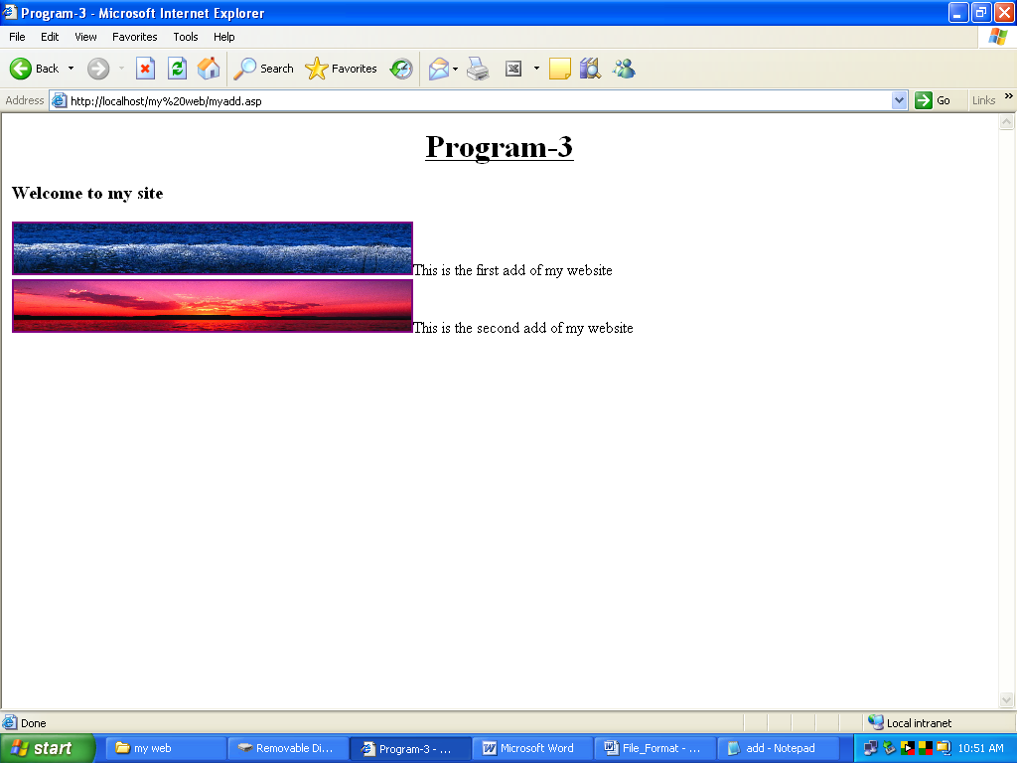

PREPARED BY :- Ashish Verma | APPROVED BY :- Er. Kanika Gupta
FORM No. SDDIET-FRM-32B Roll No. :2205405
SDDIET | SWAMI DEVI DYAL INSTITUTE OF ENGG. & TECHNOLOGY, BARWALA, PANCHKULA |  |  | LABORATORY MANUAL
SDDIET | PRACTICAL EXPERIMENT INSTRUCTION SHEET
SDDIET | PROGRAM TITLE: Write a program to show usage of Request Object.
EXPERIMENT NO.: - 4 |  | DEPTT. :- I.T. | ISSUE DATE: -
LABORATORY:- SSP LAB |  |  | SEMESTER: -7th |  | PAGE.NO: 9

41. asp

<%@language="vbscript"%>
<html>
<head>
<title>Form1</title>
</head>
<body bgcolor="#cc99ff">
<form method="get" action="p42.asp">
<h1><font face="comic sans ms" color="#990033">
<center>ENTRY FORM</center>
</font></h1>
<b>Name:</b>&nbsp;&nbsp;&nbsp;&nbsp;
<input type="text" name="name"><br>
<b>Address:</b>&nbsp;<input type="text" name="address"><br>
<b>Age:</b>&nbsp;&nbsp;&nbsp;&nbsp;&nbsp;&nbsp;&nbsp;
<select name="age">
<option value="18-20">18-20
<option value="21-25">21-25
<option value="26-35">26-35
<option value="Above 35">Above 35
</select>
<br><br>
<b>Select your course</b><br>
<input type="radio" name="course" value="B-Tech">B-Tech<br>
<input type="radio" name="course" value="M-Tech">B-Tech<br>
<input type="radio" name="course" value="B.C.A.">B.C.A.<br>
<input type="radio" name="course" value="M.C.A.">M.C.A.<br>
<br><b>Select your subjects</b></br>

<input type="checkbox" name="subject" value="ADA">ADA<br>
<input type="checkbox" name="subject" value="SSP">SSP<br>
<input type="checkbox" name="subject" value="JAVA">JAVA<br>
<input type="checkbox" name="subject" value="LINUX">LINUX<br>
<br><input type="submit" value="SUBMIT"
</FORM>
</body>
</html>

42.asp

<%@language="vbscript"%>
<html>
<head>
<title>Form2</title>
</head>
<body bgcolor="#fedcba">
<font face="monotype corsiva">
<h2><center>RECORD ENTERED ROOM</center></font></h2>
<%
dim name,subject,address,course,age
name=request.queryString("name")
address=request.queryString("address")
age=request.queryString("age")
subject=request.queryString("subject")
course=request.queryString("course")
%>
<table border=4 bordercolor="maroon">
<tr><th>NAME
<td><%=name%></tr>
<tr><th>ADDRESS
<td><%=address%></tr>
<tr><th>AGE
<td><%=age%></tr>
<tr><th>COURSE OPTED
<td><%=course%></tr>
<tr><th>SUBJECT CHOSEN
<td><%=subject%></tr>
</table>
</body>
</html>

PREPARED BY :-Ashish Verma | APPROVED BY :- Er. Kanika Gupta

FORM No. SDDIET-FRM-32B Roll No. :2205405
SDDIET | SWAMI DEVI DYAL INSTITUTE OF ENGG. & TECHNOLOGY, BARWALA, PANCHKULA |  |  | LABORATORY MANUAL
SDDIET | PRACTICAL EXPERIMENT INSTRUCTION SHEET
SDDIET | PROGRAM TITLE: 41.asp Output
EXPERIMENT NO.: - 4 |  | DEPTT. :- I.T. | ISSUE DATE: -
LABORATORY:- SSP LAB |  |  | SEMESTER: -7th |  | PAGE.NO: 11

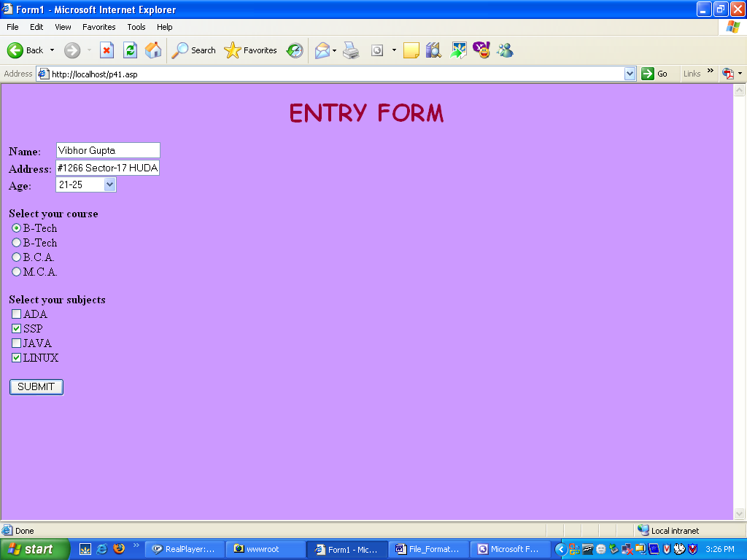

PREPARED BY :- Ashish Verma | APPROVED BY :- Er. Kanika Gupta

FORM No. SDDIET-FRM-32B Roll No. :2205405
SDDIET | SWAMI DEVI DYAL INSTITUTE OF ENGG. & TECHNOLOGY, BARWALA, PANCHKULA |  |  | LABORATORY MANUAL
SDDIET | PRACTICAL EXPERIMENT INSTRUCTION SHEET
SDDIET | PROGRAM TITLE: 42.asp Output
EXPERIMENT NO.: - 4 |  | DEPTT. :- I.T. | ISSUE DATE: -
LABORATORY:- SSP LAB |  |  | SEMESTER: -7th |  | PAGE.NO: 12

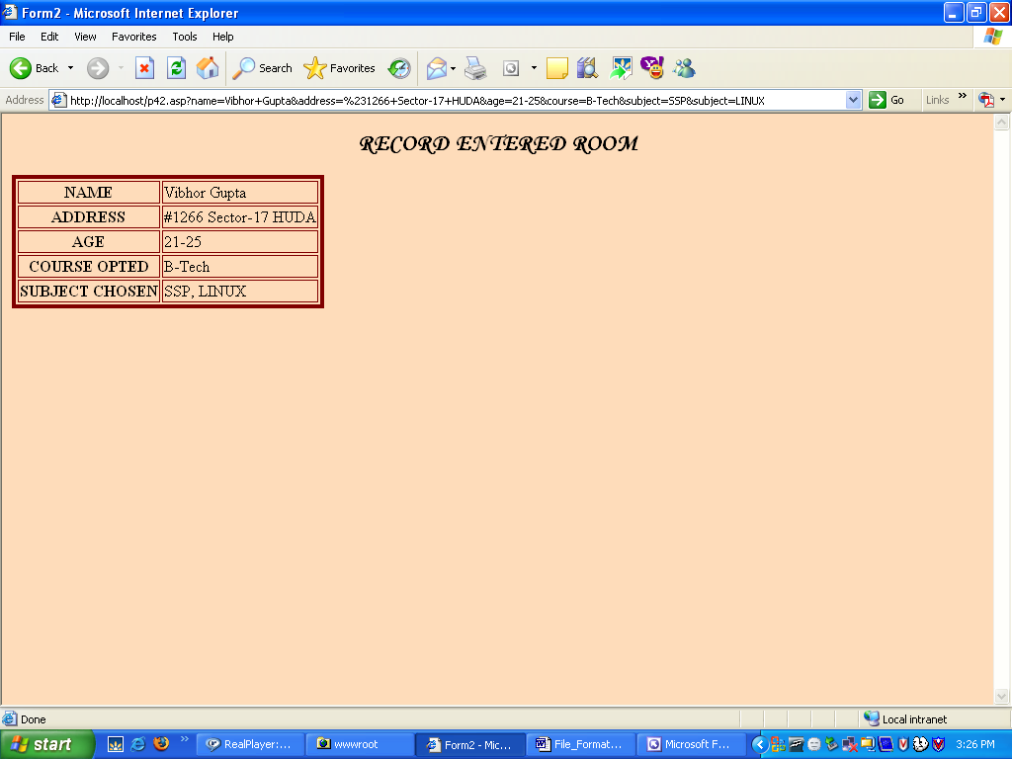

PREPARED BY :- Ashish Verma | APPROVED BY :- Er. Kanika Gupta

FORM No. SDDIET-FRM-32B Roll No. :2205405
SDDIET | SWAMI DEVI DYAL INSTITUTE OF ENGG. & TECHNOLOGY, BARWALA, PANCHKULA |  |  | LABORATORY MANUAL
SDDIET | PRACTICAL EXPERIMENT INSTRUCTION SHEET
SDDIET | PROGRAM TITLE: Write a program to display all the headers using Request Object.
EXPERIMENT NO.: - 5 |  | DEPTT. :- I.T. | ISSUE DATE: -
LABORATORY:- SSP LAB |  |  | SEMESTER: -7th |  | PAGE.NO: 13

<html>
<head>
<title>Usage Of Request Object</title>
</head>
<body>

<div align="left">

<font size="5" face="monotype corsiva">

These are the unformatted HTTP headers.These are the
exact headers that the web server sent to the
browser when this page was requested
</font><br>
</div>
<pre>
<%=Request.ServerVariables("ALL_RAW")%>
</pre>
<p align="left">
<font size="5" face="monotype corsiva">
These are the formatted HTTP headers.Note that all headers are
capitalized & begin with the <code>HTTP</code>
prefix.<br>
</font>
<pre>
<%=Request.ServerVariables("ALL_HTTP")%>
</pre>
</p>
</body>
</html>

PREPARED BY :- Ashish Verma | APPROVED BY :- Er. Kanika Gupta
FORM No. SDDIET-FRM-32B Roll No. :2205405
SDDIET | SWAMI DEVI DYAL INSTITUTE OF ENGG. & TECHNOLOGY, BARWALA, PANCHKULA |  |  | LABORATORY MANUAL
SDDIET | PRACTICAL EXPERIMENT INSTRUCTION SHEET
SDDIET | PROGRAM TITLE: Output
EXPERIMENT NO.: - 5 |  | DEPTT. :- I.T. | ISSUE DATE: -
LABORATORY:- SSP LAB |  |  | SEMESTER: -7th |  | PAGE.NO: 14

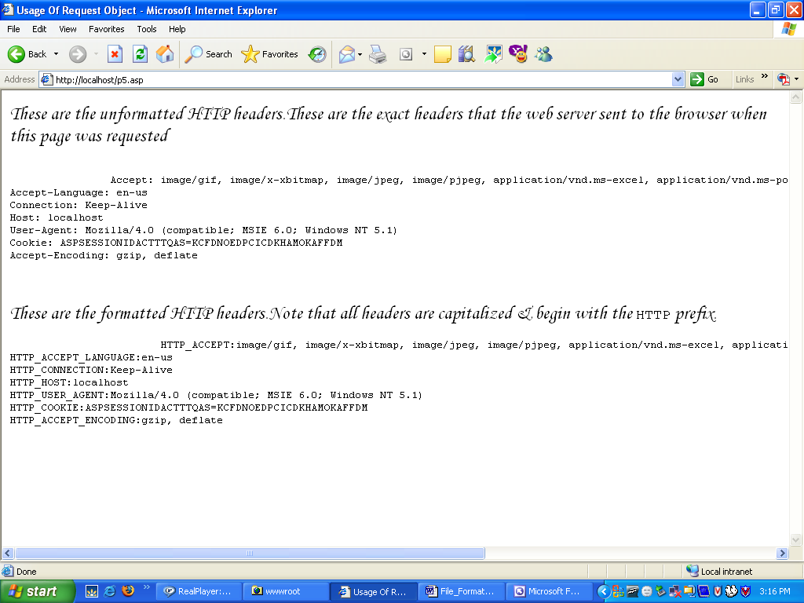

PREPARED BY :- Ashish Verma | APPROVED BY :- Er. Kanika Gupta

FORM No. SDDIET-FRM-32B Roll No. :2205405
SDDIET | SWAMI DEVI DYAL INSTITUTE OF ENGG. & TECHNOLOGY, BARWALA, PANCHKULA |  |  | LABORATORY MANUAL
SDDIET | PRACTICAL EXPERIMENT INSTRUCTION SHEET
SDDIET | PROGRAM TITLE: Write a Program to Implement session Object in ASP
EXPERIMENT NO.: - 6 |  | DEPTT. :- I.T. | ISSUE DATE: -
LABORATORY:- SSP LAB |  |  | SEMESTER: -7th |  | PAGE.NO: 15

61.asp

<html>
<head>
<title>Session object</title>
</head>
<body bgcolor="pink">
<form method="POST" action="p62.asp">
<center><font size=5>Enter the Information</font></center>
<br><br>
<p align="center"><font size=4>Name:<input type="text" name="name" size="20"></p>
<p align="center">Password:<input type="password" name="password" size="20"></p>
<p align="center"><input type="submit" value="Submit" name="B1"><br><br>
<input type="reset" value="Reset" name="B2"></p></font>
</form>
</body>
</html>

62.asp

<% @language="vbscript" %>
<html>
<head>
<title>Untitled Document</title>
<% name=request("name")
pass=request("password")
session("n1")=name
session("p1")=pass
n1=session("n1")
p1=session("p1")
%>
</head>
<body bgcolor="pink">
<form method="POST" action="p63.asp">
<p align="center"><font size=5>Hello! <%response.write(n1)%></p>
<p align="center">Your Password is: <%response.write(p1)%></p>
<p align="center">Age:<input type="text" name="age" size="20"></p>
<p align="center">Color:<input type="text" name="color" size="20"></font></p>
<p align="center"><input type="submit" value="Submit" name="B1">
<input type="reset" value="Reset" name="B2"></p>
</form>
</body>
</html>

63.asp
<% @language="vbscript" %>
<html>
<head>
<title>Untitled Document</title>
<meta http-equiv="Content-Type" content="text/html;charset=iso-8859-1">
<% age=request("age")
color=request("color")
%>
</head>
<body bgcolor="pink">
<form method="POST" action="p63.asp">
<font size=6><center>This Information is carried from first page</center></font>
<p align="center">
<font face="Lucida Sans Unicode"><u>Hello
<%response.write(session("n1"))%></u></font></p>
<p align="center">
<font face="Lucida Sans Unicode"><u>Your Password is
<%response.write(session("p1"))%></u></font></p>
<p align="center">
<font face="Lucida Sans Unicode"><u>Your Age is
<%response.write(age)%></u></font></p>
<p align="center">
<font face="Lucida Sans Unicode"><u>Your favourite color is
<%response.write(color)%></u></font></p>
</form>
</body>
</html>

PREPARED BY :- Ashish Verma | APPROVED BY :- Er. Kanika Gupta
FORM No. SDDIET-FRM-32B Roll No. :2205405
SDDIET | SWAMI DEVI DYAL INSTITUTE OF ENGG. & TECHNOLOGY, BARWALA, PANCHKULA |  |  | LABORATORY MANUAL
SDDIET | PRACTICAL EXPERIMENT INSTRUCTION SHEET
SDDIET | PROGRAM TITLE: 61.asp Output
EXPERIMENT NO.: - 6 |  | DEPTT. :- I.T. | ISSUE DATE: -
LABORATORY:- SSP LAB |  |  | SEMESTER: -7th |  | PAGE.NO: 17

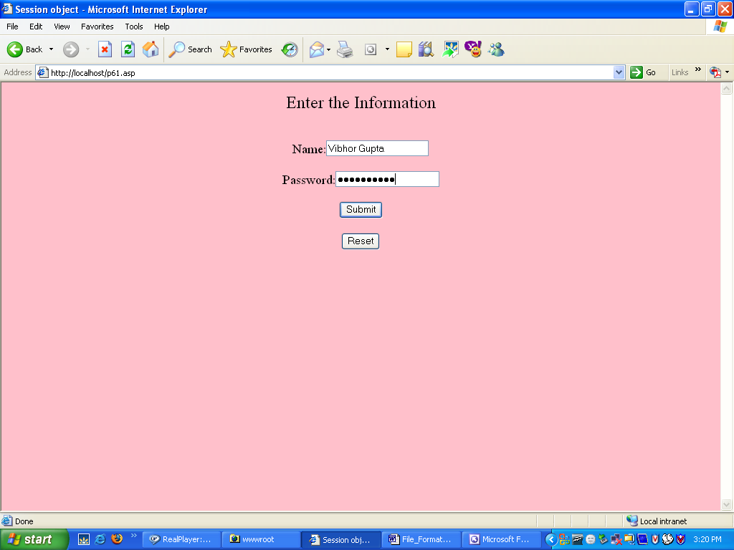

PREPARED BY :- Ashish Verma | APPROVED BY :- Er. Kanika Gupta

FORM No. SDDIET-FRM-32B Roll No. :2205405
SDDIET | SWAMI DEVI DYAL INSTITUTE OF ENGG. & TECHNOLOGY, BARWALA, PANCHKULA |  |  | LABORATORY MANUAL
SDDIET | PRACTICAL EXPERIMENT INSTRUCTION SHEET
SDDIET | PROGRAM TITLE: 62.asp Output
EXPERIMENT NO.: - 6 |  | DEPTT. :- I.T. | ISSUE DATE: -
LABORATORY:- SSP LAB |  |  | SEMESTER: -7th |  | PAGE.NO: 18

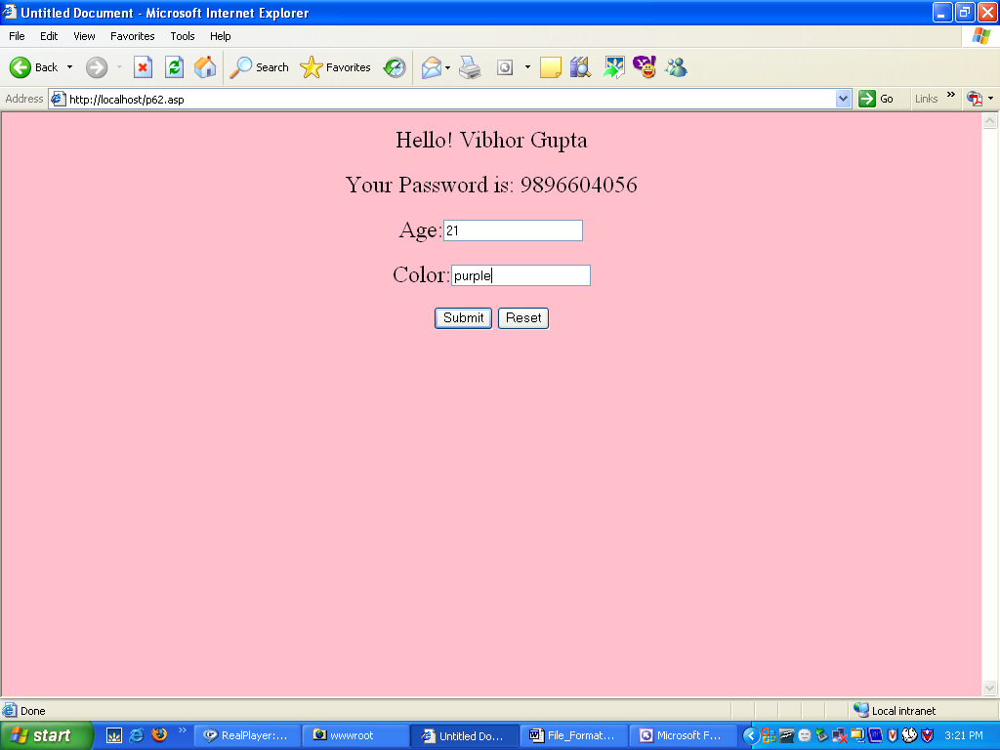

PREPARED BY :- Ashish Verma | APPROVED BY :- Er. Kanika Gupta

FORM No. SDDIET-FRM-32B Roll No. :2205405
SDDIET | SWAMI DEVI DYAL INSTITUTE OF ENGG. & TECHNOLOGY, BARWALA, PANCHKULA |  |  | LABORATORY MANUAL
SDDIET | PRACTICAL EXPERIMENT INSTRUCTION SHEET
SDDIET | PROGRAM TITLE: 63.asp Output
EXPERIMENT NO.: - 6 |  | DEPTT. :- I.T. | ISSUE DATE: -
LABORATORY:- SSP LAB |  |  | SEMESTER: -7th |  | PAGE.NO: 19

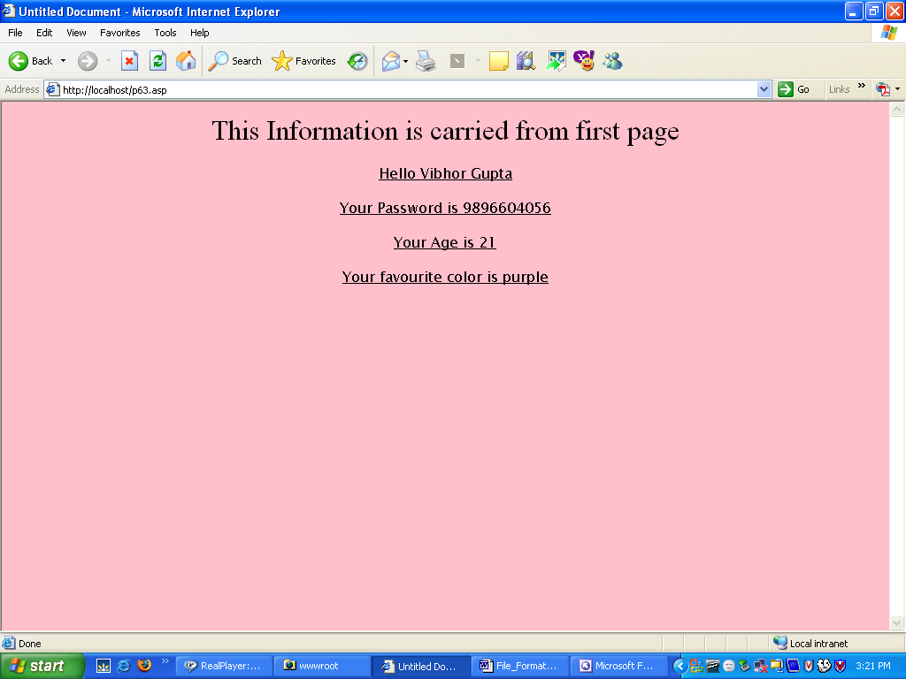

PREPARED BY :- Ashish Verma | APPROVED BY :- Er. Kanika Gupta

FORM No. SDDIET-FRM-32B Roll No. :2205405
SDDIET | SWAMI DEVI DYAL INSTITUTE OF ENGG. & TECHNOLOGY, BARWALA, PANCHKULA |  |  | LABORATORY MANUAL
SDDIET | PRACTICAL EXPERIMENT INSTRUCTION SHEET
SDDIET | PROGRAM TITLE: Write a Program to Implement Application Object.
EXPERIMENT NO.: - 7 |  | DEPTT. :- I.T. | ISSUE DATE: -
LABORATORY:- SSP LAB |  |  | SEMESTER: -7th |  | PAGE.NO: 20

Form1.asp

<% @LANGUAGE="VBSCRIPT" %>
<html>
<head>
<title>Application object</title>
</head>
<body>
Let's retrive the values of Application Variables:
<p>my App Variable=<%=Application("my App Variable")%><br>
another App Variable=<%=("another App Variable")%><br>
Now,Let's set the Variable:<br>
<%
Application.Lock
Application("my App Variable")=Now()
Application("another App Variable")=CStr(Clnt(Application("another App Variable"))+1)
Application.Unlock
%>
Variables set-<a href="10.asp">Click here</a>to reload the page to view
</body>
</html>

10.asp

<SCRIPT LANGUAGE="VBscript"RUNAT="Server">
sub Application_OnStart
Application("my App Variablr")=""
Application("another App Variable")=0
End Sub
</SCRIPT>

PREPARED BY :- Ashish Verma | APPROVED BY :- Er. Kanika Gupta
FORM No. SDDIET-FRM-32B Roll No. :2205405
SDDIET | SWAMI DEVI DYAL INSTITUTE OF ENGG. & TECHNOLOGY, BARWALA, PANCHKULA |  |  | LABORATORY MANUAL
SDDIET | PRACTICAL EXPERIMENT INSTRUCTION SHEET
SDDIET | PROGRAM TITLE: Output
EXPERIMENT NO.: - 7 |  | DEPTT. :- I.T. | ISSUE DATE: -
LABORATORY:- SSP LAB |  |  | SEMESTER: -7th |  | PAGE.NO: 21

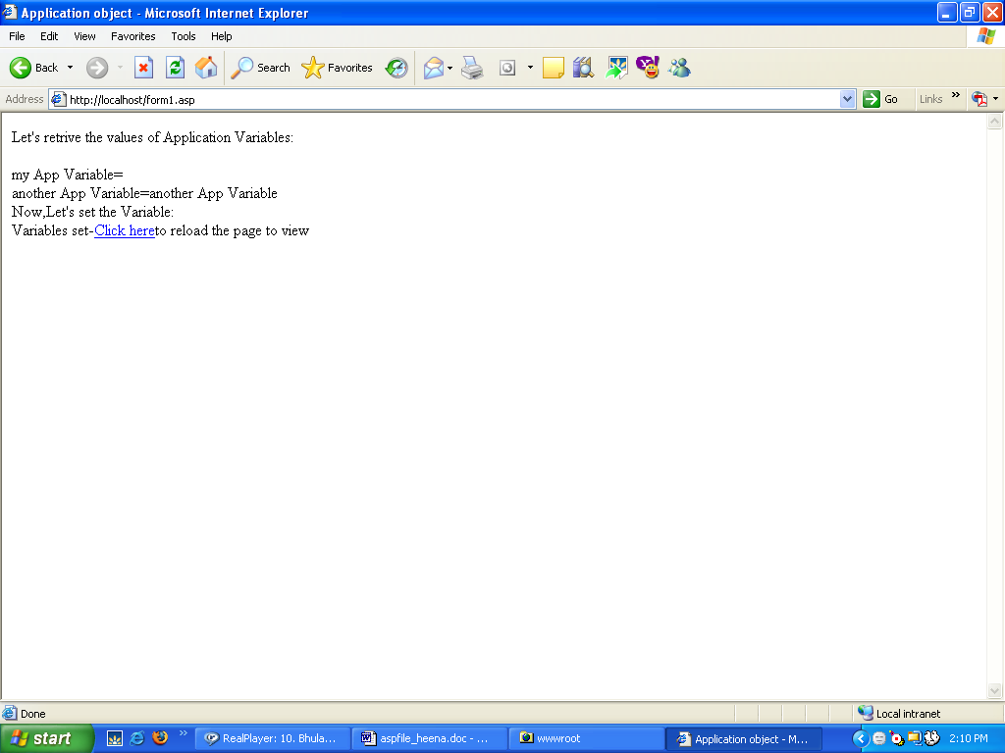

PREPARED BY :- Ashish Verma | APPROVED BY :- Er. Kanika Gupta

FORM No. SDDIET-FRM-32B Roll No. :2205405
SDDIET | SWAMI DEVI DYAL INSTITUTE OF ENGG. & TECHNOLOGY, BARWALA, PANCHKULA |  |  | LABORATORY MANUAL
SDDIET | PRACTICAL EXPERIMENT INSTRUCTION SHEET
SDDIET | PROGRAM TITLE: Write a Program for redirecting and Executing files on server.
EXPERIMENT NO.: - 8 |  | DEPTT. :- I.T. | ISSUE DATE: -
LABORATORY:- SSP LAB |  |  | SEMESTER: -7th |  | PAGE.NO: 22

81.asp

<% @LANGUAGE=VBSCRIPT%>
<html>
<head>
<title>Transfering and execute file on server</title>
</head>
<body>
<font face="Bookman Old Style">
<b><u>Server.executemethod:</u></b><br>
<%
response.write("Line1 in File1 EXECUTE method</br>")
server.execute("p82.asp")
response.write("Line1 in File2 EXECUTE method</br>")
%>
<b><u>Server.transfer method:</u></b><br>
<%
response.write("Line1 in File1 TRANSFER method</br>")
server.transfer("p82.asp")
response.write("Line1 in File2 TRANSFER method</br>")
%>
</font>
</body>
</html>

82.asp

<% @LANGUAGE=VBSCRIPT %>
<html>
<head>
<title>Transfering and execute file on server</title>
</head>
<body>
<b>
<%
response.write("we are now in second file</br>")
response.write("Line1 in file2</br>")
response.write("Line2 in file2</br>")
%>
</b>
</body>
</html>

PREPARED BY :- Ashish Verma | APPROVED BY :- Er. Kanika Gupta
FORM No. SDDIET-FRM-32B Roll No. :2205405
SDDIET | SWAMI DEVI DYAL INSTITUTE OF ENGG. & TECHNOLOGY, BARWALA, PANCHKULA |  |  | LABORATORY MANUAL
SDDIET | PRACTICAL EXPERIMENT INSTRUCTION SHEET
SDDIET | PROGRAM TITLE: 81.asp Output
EXPERIMENT NO.: - 8 |  | DEPTT. :- I.T. | ISSUE DATE: -
LABORATORY:- SSP LAB |  |  | SEMESTER: -7th |  | PAGE.NO: 24

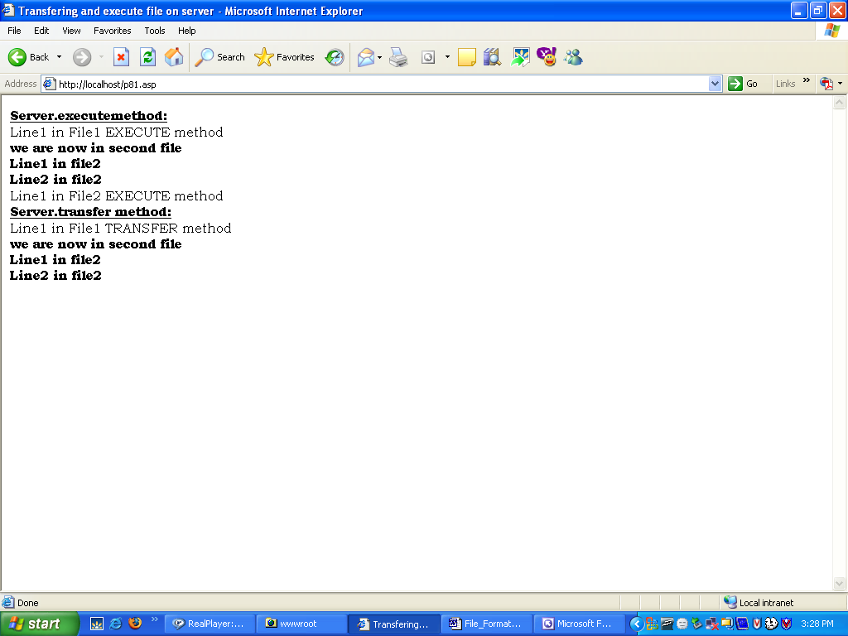

PREPARED BY :- Ashish Verma | APPROVED BY :- Er. Kanika Gupta
FORM No. SDDIET-FRM-32B Roll No. :2205405
SDDIET | SWAMI DEVI DYAL INSTITUTE OF ENGG. & TECHNOLOGY, BARWALA, PANCHKULA |  |  | LABORATORY MANUAL
SDDIET | PRACTICAL EXPERIMENT INSTRUCTION SHEET
SDDIET | PROGRAM TITLE: 82.asp Output
EXPERIMENT NO.: - 8 |  | DEPTT. :- I.T. | ISSUE DATE: -
LABORATORY:- SSP LAB |  |  | SEMESTER: -7th |  | PAGE.NO: 25

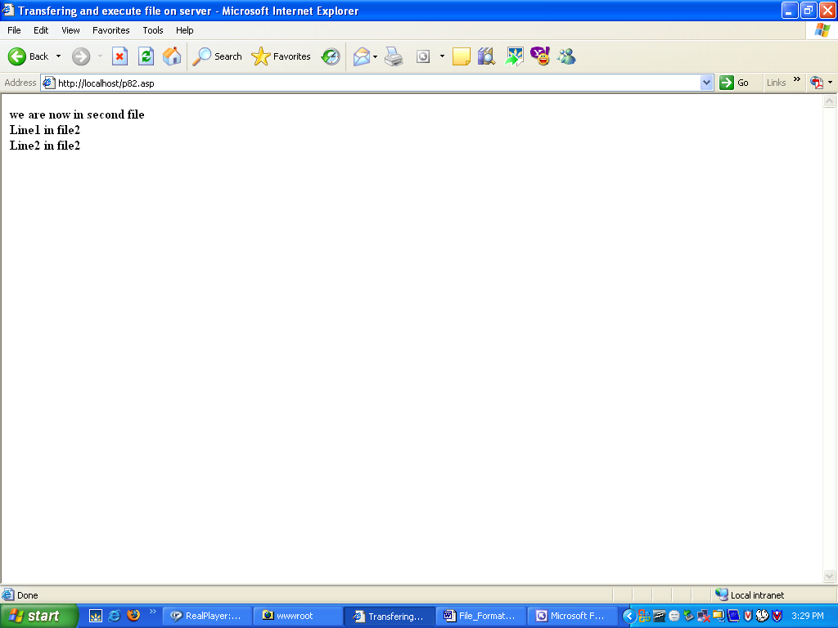

PREPARED BY :- Ashish Verma | APPROVED BY :- Er. Kanika Gupta
FORM No. SDDIET-FRM-32B Roll No. :2205405
SDDIET | SWAMI DEVI DYAL INSTITUTE OF ENGG. & TECHNOLOGY, BARWALA, PANCHKULA |  |  | LABORATORY MANUAL
SDDIET | PRACTICAL EXPERIMENT INSTRUCTION SHEET
SDDIET | PROGRAM TITLE: Write a Program for determining the Properties of File Object.
EXPERIMENT NO.: - 9 |  | DEPTT. :- I.T. | ISSUE DATE: -
LABORATORY:- SSP LAB |  |  | SEMESTER: -7th |  | PAGE.NO: 26

<% @LANGUAGE=VBSCRIPT %>
<html>
<head>
<title>file properties</title>
</head>
<body>
<h1><center><u>File Properties</u></center></h1>
<b><i>
<font type="arial" , size=4>
<%
Dim fs,f0,f1
Set fs=Server.CreateObject("scripting.FileSystemObject")
Set f0=fs.GetFile("C:\WINDOWS\Cursors\3dgarro.cur")
set f1=fs.GetFile("C:\Program Files\Common Files\Services\bigfoot.bmp")
name1=fs.GetDriveName("C:\WINDOWS\Cursors\3dgarro.cur")
name2=fs.GetDriveName("C:\Program Files\Common Files\Services\bigfoot.bmp")
%><br>
<%
response.write("The name of the File is: ")
response.write(fs.GetBaseName("C:\WINDOWS\Cursors\3dgarro.cur"))
response.write("<br>")
response.write("The attributes of files are:")
response.write(f0.attributes)
%><br>
<%
response.write("File reside on drives: ")
response.write(name1)
%><br>
<%
response.write("File created:options "& f0.DateCreated)
%><br><br><br>
<%
response.write("The name of the File is: ")
response.write(fs.GetBaseName("C:\Program Files\Common Files\Services\bigfoot.bmp"))
response.write("<br>")
response.write("The attributes of files are:")
response.write(f1.attributes)
%><br>
<%
response.write("File reside on drives: ")
response.write(name2)
%><br>
<%
response.write("File created:options "& f0.DateCreated)
%>

<%
set f0=nothing
set fs=nothing
set f1=nothing
%>
</i></b>
</body>
</html>

PREPARED BY :- Ashish Verma | APPROVED BY :- Er. Kanika Gupta
FORM No. SDDIET-FRM-32B Roll No. :2205405
SDDIET | SWAMI DEVI DYAL INSTITUTE OF ENGG. & TECHNOLOGY, BARWALA, PANCHKULA |  |  | LABORATORY MANUAL
SDDIET | PRACTICAL EXPERIMENT INSTRUCTION SHEET
SDDIET | PROGRAM TITLE: Output
EXPERIMENT NO.: - 9 |  | DEPTT. :- I.T. | ISSUE DATE: -
LABORATORY:- SSP LAB |  |  | SEMESTER: -7th |  | PAGE.NO: 28

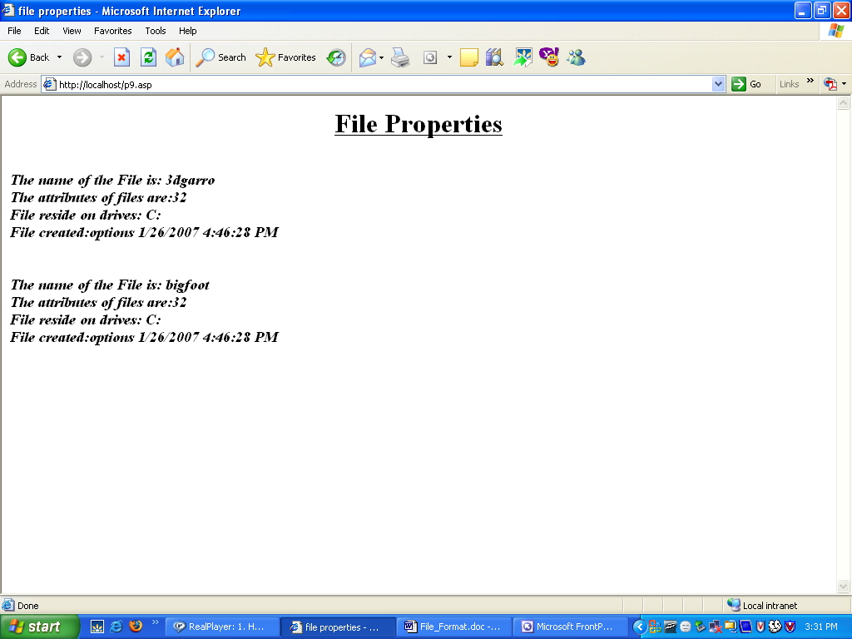

PREPARED BY :- Ashish Verma | APPROVED BY :- Er. Kanika Gupta
FORM No. SDDIET-FRM-32B Roll No. :2205405
SDDIET | SWAMI DEVI DYAL INSTITUTE OF ENGG. & TECHNOLOGY, BARWALA, PANCHKULA |  |  | LABORATORY MANUAL
SDDIET | PRACTICAL EXPERIMENT INSTRUCTION SHEET
SDDIET | PROGRAM TITLE: Write a Program to show usage of Response Object
EXPERIMENT NO.: - 10 |  | DEPTT. :- I.T. | ISSUE DATE: -
LABORATORY:- SSP LAB |  |  | SEMESTER: -7th |  | PAGE.NO: 29

<% @LANGUAGE=VBSCRIPT %>
<html>
<head>
<title>Program No-10</title>
</head>
Hello
<br>
<%
response.buffer="true"
response.write("Before clear")
%>
<br>
<%
response.clear
%><center><h1><u>Methods-Clear , End ,Flush</u></h1></center><br><br>
<p><font size=4>I write some text, but I will control when the text will be sent to the browser.</p>
<p>The Flush method sends buffered HTML output immediately</p>
<% Response.Flush %>
<p>I am writing some text. The output will show the text written before the end method is used<% Response.End %> It's too late to write more!</p>
</font>
</body>
</html>

PREPARED BY :- Ashish Verma | APPROVED BY :- Er. Kanika Gupta
FORM No. SDDIET-FRM-32B Roll No. :2205405
SDDIET | SWAMI DEVI DYAL INSTITUTE OF ENGG. & TECHNOLOGY, BARWALA, PANCHKULA |  |  | LABORATORY MANUAL
SDDIET | PRACTICAL EXPERIMENT INSTRUCTION SHEET
SDDIET | PROGRAM TITLE: Output
EXPERIMENT NO.: - 10 |  | DEPTT. :- I.T. | ISSUE DATE: -
LABORATORY:- SSP LAB |  |  | SEMESTER: -7th |  | PAGE.NO: 30

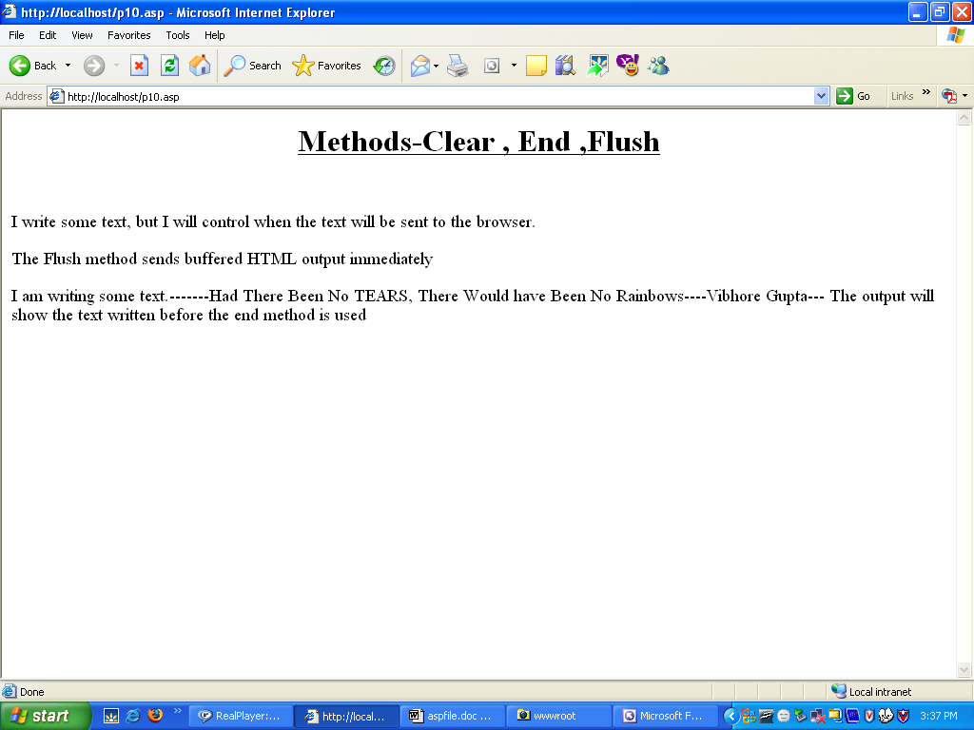

PREPARED BY :- Ashish Verma | APPROVED BY :- Er. Kanika Gupta

