INDEX

S.No | Name Of The Article | Page No. | T.Sign
1 | An introduction to VB.Net. | 1
2 | Write a program to perform arithmetic operators on on nos. | 11
3 | Write a program to create a notepad. | 16
4 | Write a program to design a calculator. | 21
5 | Write a program to add the 1 to 100 nos. | 20
6 | Write a program to change the options using msgbox function | 25
7 | Write a program on vertical and hor scrollbar control. | 29
8) | Write a program to change the color of background of window using radio buttons. | 32

Program: 1

TITLE: An introduction to visual basic.NET .

Welcome to the fascinating world of Visual Basic.NET. Visual Basic.NET is a component of Visual Studio.NET.

With its release for the .NET platform, the Visual Basic language has undergone dramatic changes.

For example:

- The language itself is now fully object-oriented.

-  Applications and components written in Visual Basic .NET have full access to the .NET Framework, an extensive class library that provides system and application services.

- All applications developed using Visual Basic .NET run within a managed runtime environment, the .NET common language runtime.

- In this introduction, I briefly discuss these changes and other changes before showing you three very simple, but complete, Visual Basic .NET applications.

What Is Visual Basic .NET?

Visual Basic .NET is the next generation of Visual Basic, but it is also a significant departure from previous generations. Experienced Visual Basic 6 developers will feel comfortable with Visual Basic .NET code and will recognize most of its constructs. However, Microsoft has made some changes to make Visual Basic .NET a better language and an equal player in the .NET world. These include such additions as a Class keyword for defining classes and an Inherits keyword for object inheritance, among others. Visual Basic 6 code can't be compiled by the Visual Basic .NET compiler without significant modification. The good news is that Microsoft has provided a migration tool to handle the task (mostly, anyway).

What Is the Microsoft .NET Framework?

The .NET Framework encompasses the following:
A new way to expose operating system and other APIs. For years, the set of Windows functionality that was available to developers and the way that functionality was invoked were dependent on the language environment being used.
For example, the Windows operating system provides the ability to create windows (obviously). Yet, the way this feature was invoked from a C++ program was dramatically different from the way it was invoked from a Visual Basic program. With .NET, the way that operating system services are invoked is uniform across all languages (including code embedded in ASP.NET pages).

This portion of .NET is commonly referred to as the .NET Framework class library.
A new infrastructure was established for managing application execution. To provide a number of sophisticated new operating-system services—including code-level security, cross-language class inheritance, cross-language type compatibility, and hardware and operating-system independence, among others—Microsoft developed a new runtime environment known as the Common Language Runtime (CLR). The CLR includes the Common Type System (CTS) for cross-language type compatibility and the Common Language Specification (CLS) for ensuring that third-party libraries can be used from all .NET-enabled languages. To support hardware and operating-system independence, Microsoft developed the Microsoft Intermediate Language (MSIL, or just IL). IL is a CPU-independent machine language-style instruction set into which .NET Framework programs are compiled. IL programs are compiled to the actual machine language on the target platform prior to execution (known as just-in-time or JIT, compiling). IL is never interpreted.
A new web server paradigm.

To support high-capacity web sites, Microsoft has replaced its Active Server Pages (ASP) technology with ASP.NET. While developers who are used to classic ASP will find ASP.NET familiar on the surface, the underlying engine is different, and far more features are supported. ASP.NET web page code is now compiled rather than interpreted, greatly increasing execution speed.
A new focus on distributed-application architecture.

Visual Studio .NET provides top-notch tools for creating and consuming web services -vendor-independent software services that can be invoked over the Internet. The .NET Framework is designed top to bottom with the Internet in mind.
For example, ADO.NET, the next step in the evolution of Microsoft's vision of "universal data access," assumes that applications will work with disconnected data by default. In addition, the ADO.NET classes provide sophisticated XML capabilities, further increasing their usefulness in a distributed environment.

History of VB.Net

For years, the design of Visual Basic has reflected a compromise between power and simplicity. In exchange for isolating intermediate developers from the complexities and dangers of API programming, VB developers accepted certain limitations. The compiled VB code could not interact directly with the Windows API (usually written in C++), but instead they would interface through a runtime module that would handle the dirty work of data allocation and dereferencing. Because of this situation, a gulf developed between VB and C++ programmers. In fact, many C++ programmers looked down at VB as merely suitable for Rapid Application Development and not as an appropriate tool for serious enterprise development. They also resented having to write wrappers to allow the VB developers to access new Windows APIs. This has all changed in VB.NET. Now, the code created by Visual Basic developers and C++ developers both interface with Windows in the same way—through the CLR. (For that matter, so do other new languages, such as C# or JavaScript.NET.)

Convergence regarding VB.NET

One of the advantages of VB.NET is that it is now possible to use VB to develop applications that previously needed to be developed in lower-level languages, without losing the traditional advantages of VB development. Whether you are a developer or a manager, your job involves analyzing the tradeoffs of the various tools available to better illustrate the convergence of these two platforms, detail given below compares the ways in which VB and C handle four critical issues, both historically and in the .NET environment.

Runtime Required: Starting with VB 5.0, Microsoft made the claim that Visual Basic could actually compile to a true executable, but it is probably more accurate to say that the runtime module was just smaller and more transparent to the user. By contrast, C++ has never required a runtime module.

Interface Model: With the CLR, the code compiled is no longer the exact code executed, but rather it is translated on the client machine. (Some of the advantages of this approach are described in more detail in the New Compiler section.) In previous versions of VB and C++, the code was compiled to use COM, but in VB.NET and C#, the code is compiled to CLR.

Memory Leaks: One of the traditional advantages of VB is that memory was managed responsibly by the compiled executable, and this advantage remains in VB.NET, although the work is now done in the CLR. (By contrast, poorly written C++ code often created these errors because memory was not reallocated after it was used.)

Inheritance Supported: This is probably the most important advance in VB.NET, and it is covered in the next section. (Starting with Version 5.0, VB supported a rough simulation of inheritance that is also described in the next section.)

An introduction to VB.NET IDE:

IDE stands for Integrated Development Environment. The various tool that are required for developing a VB.NET application are available with in VB.NET, and all these tools together are referred to as IDE.VB.NET comes as a component of Microsoft visual Studio.NET, visual C++.NET, visual C#.NET are bundled together for the convenience of programmers; and all these component enjoy the common IDE.now let’s we take some introduction about the Microsoft visual studio.NET.

Opening an existing window:

The first thing to know about Visual Studio .NET is that Microsoft has done the same thing for their development software that they did for their development languages: they integrated everything. We learned earlier that C# and VB.NET are close cousins because they're both really the .NET Framework under a thin skin of code syntax. VS.NET is even more integrated. So it shouldn't surprise you to discover that the VS.NET IDE is the same for all of the .NET languages too.

The VS.NET Start Page:
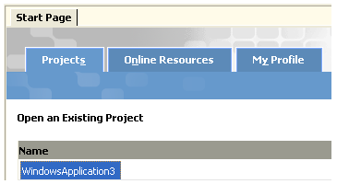

Many of the "global" resources in VS.NET are on the VS.NET Start Page. The links available from the Start Page are organized into three tabs. (See the illustration.) If you have closed the Start Page and you want to display it again, Microsoft decided to put the link to the Start Page on the Help menu.

One of the first configuration tasks you should do is select a "profile" that presents a view of VS.NET that will be most helpful to you. On the My Profile tab, in addition to an overall "style" of programming (of course, we'll select the "Visual Basic" style), you can select these differences...
- Keyboard Schemes - to change the default keys in some actions.
- Window Layout - sets the default position of windows.
- Help Filter - to select only the Help content that applies to the type of programming you do.
- Show Help - Chooses whether to show help as an integrated part of the IDE or in its own window.
- At Startup - What VS.NET displays when you first open the IDE.
In addition to integrating VS.NET across their development languages and platforms, Microsoft also integrated it with Windows and the MSDN web site. So, when you select the Start Page tab at the top of your VS.NET environment, the right side is a menu of links to a whole community of Microsoft help and reference sites. (Note that these links are only available if you're connected to the Internet when you start VS.NET.)You can even run processes like Windows Update from the VS.NET Start Page just as you can from the Start Button in Windows itself.
After you work with VS.NET, you will be convinced that it's one of the most 'configurable' systems you have ever seen. When you have selected a project to open after configuring options on the Start Page, you will see a screen something like this illustration of a typical VS.NET desktop. Since this view still shows only part of the windows that are available to you, it should be enough to convince anyone that it's a complex system just packed full of different programming tools and features.
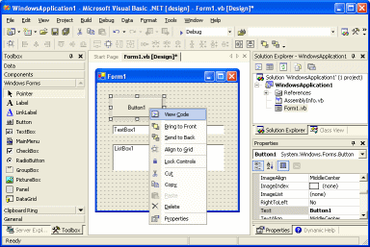

The basic idea is the same as VB 6. In a standard Windows Application, you can drag and drop components from the Toolbox onto a design Form. Then you select Properties for components and enter program code into a code window. Like VS 6, VS.NET includes a full featured Debug environment where you can watch your code execute statement at a time. Once your program runs the way you want it to, you can Build an executable version of your program.
One way to look at all of the new stuff in VS.NET is to classify things into these two categories:
- IDE Features
- Language Features
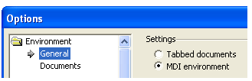
The Language Features are the things you have to know about Visual Basic .NET and how to use it in Visual Studio. For example, how to add References, new program Modules, and what all the components in the Toolbox are for. Buried in the General page of the Environment folder in the Options dialog box under the Tools menu item - you will find a little noticed setting which allows you to work in either Multiple Document Interface (MDI) or Tabbed Documents mode. The default is Tabbed Documents mode and that's what the rest of this lesson will assume. If you select the MDI mode, however, you can tile or cascade the windows but your ability to dock them is lost. If you want something that looks just a little more like the old Visual Studio 6, MDI mode will help, but MDI style windows seem to be losing popularity compared with docking windows.
The Files behind the IDE:
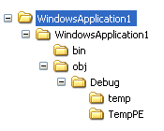
Another new thing about VB.NET ... and Visual Studio .NET ... is the file structure that is maintained behind the scenes. One of the benefits that this brings is the ability to deploy the app's that you write by simply copying the files to a directory - sometimes called XCopy deployment because it's just like the way we used to do it with the old DOS XCopy command. In fact, there's a new trend back to actually using XCopy in a DOS batch file to deploy simple applications.
Between the times of DOS ... the real DOS before Windows ... and .NET, DLL's had to be "registered" so the application would know how to find them. In this case, the DLL is known only by its name and location to an app that needs to use it. If someone updates a DLL and copies it over the top of one with the same name (and this happens all too often when large and complex systems are installed), the system breaks.
Another new thing about VB.NET ... and Visual Studio .NET ... is the file structure that is maintained behind the scenes. One of the benefits that this brings is the ability to deploy the app's that you write by simply copying the files to a directory - sometimes called XCopy deployment because it's just like the way we used to do it with the old DOS XCopy command. In fact, there's a new trend back to actually using XCopy in a DOS batch file to deploy simple applications.
We're going to look at the files saved by Visual Studio, but there are two things that need to be emphasized at this point.
- You won't be able to see all of the files unless you change your folder view options (Tools > Folder Options > View in Windows XP). The Windows default is to not be able to view "hidden" files and folders. Microsoft makes this the default because these files and folders are intended to be changed only with a tool ... like Visual Studio .NET!

- And this brings up the second thing you need to know. The main tool you will use to change some of these is the Solution Explorer window in VS.NET. So, although we're going to look the files and folders for purposes of understanding VS.NET, you should actually manage your programming solution in Visual Studio.
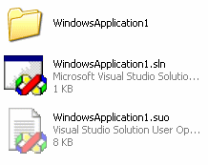
Before you write even one line of code, Visual Studio creates a couple of solution files at the top level of your application folder structure. These files keep track of the configuration of your solution and the options you have selected. A VS.NET Solution contains projects (and some other information) and projects contain the references, data connections, folders, and files that you need to create your application. You should never have to change either of them except through VS.NET. The rest of your solution is in the folder that is also created when you start a new project. The files here contain forms, source files, and classes in the project.
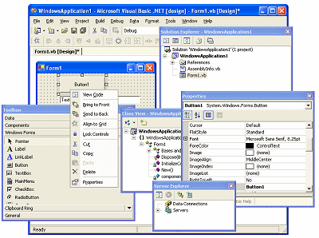
In Tabbed Documents mode, the ability to rearrange all of your windows into docked or tabbed windows gives you as much control over how your development environment looks as you could ever wish for. You could undock all of the windows and have one that looks like this. Notice that these new windows overlap the borders of the parent. Microsoft calls these Floating windows.
Alternatively, you could dock (a platform at which anything is loaded or unloaded) all of the windows and then drag them to tabbed positions and end up with one "utility window" that looks something like this. All of this is done by dragging and dropping the windows using "click and hold" movements on the Title Bar with the left mouse button. If you haven't done it before, it will probably take some practice before you can do it quickly and easily. Remember ... your "Environment" must be set to Tabbed Documents mode before you can do this. And double clicking the Title Bar will reset the whole thing to tiled windows again. It's a dynamic environment!
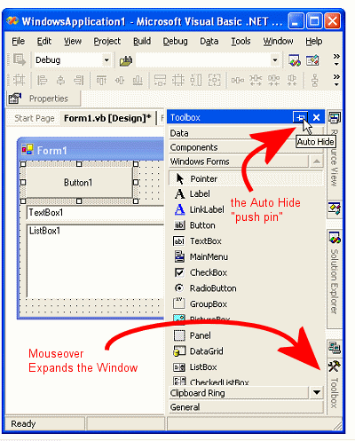
Another new trick is the use of the Auto Hide "push pin" to move windows to tabs that line up along the sides of the window, or expand out when you sweep the mouse over them. Clicking the push pin will "pin" the window in a displayed position so you can work with it. But if you just wanted to check some information in the window, it disappears back against the sides of the window when the mouse pointer isn't over it. When the window is expanded, you can click and drag inside the border to make all the information visible just like you would a normal window.
This combination makes maximum use of your monitor area while still making all of the windows you need available in a single mouse motion and it's my favorite configuration for working.
If a window is floating and you want to move it into an Auto Hide position against one margin, you first have to dock it to the side you want it to be on. Then click the Auto Hide push pin to make it disappear into a tab on that margin.
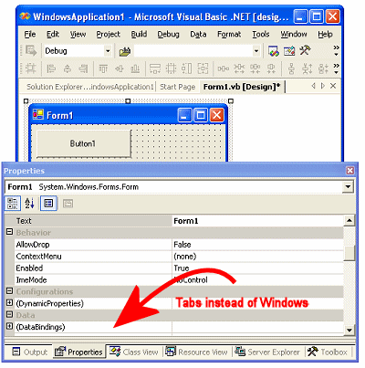
One thing to keep in mind if you're moving windows around a lot is that you can normally only dock windows once they're "pinned" to the desktop. If they're in Auto Hide mode, then you just can't select them and move them around. So if you want to move a window, make sure it's pinned first.
If you move a lot of windows to one margin (usually - more than three, depending on your monitor size and settings), you can't see the tabs for some of them because they don't resize automatically like, for example, the Windows XP Task Bar. VS.NET has another trick for this. Right click on the margin and you can select the window you want from a context menu. And finally, after all this experimentation, you might find that you have such a confused configuration of windows, tabs, and pop out menus that you just want to get things back to normal. We've got you covered! Reset your window layout using Tools > Options > Environment > General. Click the Reset Window Layout button.
Minimum Hardware Requirements for Installing Visual Studio.NET

Hardware Type Minimum Requirement Recommended

Processor Pentium 2 processor with Pentium 3 processor with
a speed of 450 MHz a speed of 600 MHz

Memory 128MB 256MB

Hard Disk Space 3GB 3GB (May be greater)

Video Settings 800 x 600, 256 colors High Color 16-bit

CD-ROM Required Required

Program: 2

TITLE: Write a program to perform arithmetic operators on nos.

Public Class Form1
Inherits System.Windows.Forms.Form

#Region " Windows Form Designer generated code "

Private Sub Button1_Click(ByVal sender As System.Object, ByVal e As System.EventArgs) Handles Button1.Click
Dim A As Integer
Dim B As Integer
Dim C As Integer
A = TextBox1.Text
B = TextBox2.Text
C = A + B
TextBox3.Text = C

End Sub

Private Sub Button2_Click(ByVal sender As System.Object, ByVal e As System.EventArgs) Handles Button2.Click
Dim A As Integer
Dim B As Integer
Dim C As Integer
A = TextBox1.Text
B = TextBox2.Text
C = A - B
TextBox3.Text = C
End Sub

Private Sub Button3_Click(ByVal sender As System.Object, ByVal e As System.EventArgs) Handles Button3.Click
Dim A As Integer
Dim B As Integer
Dim C As Integer
A = TextBox1.Text
B = TextBox2.Text
C = A * B
TextBox3.Text = C
End Sub

Private Sub Button4_Click(ByVal sender As System.Object, ByVal e As System.EventArgs) Handles Button4.Click
Dim A As Integer
Dim B As Integer
Dim C As Integer
A = TextBox1.Text
B = TextBox2.Text
C = A / B
TextBox3.Text = C
End Sub

Private Sub Button5_Click(ByVal sender As System.Object, ByVal e As System.EventArgs) Handles Button5.Click
Dim A As Integer
Dim B As Integer
Dim C As Integer
A = TextBox1.Text
B = TextBox2.Text
C = A Mod B
TextBox3.Text = C
End Sub

Private Sub TextBox3_TextChanged(ByVal sender As System.Object, ByVal e As System.EventArgs) Handles TextBox3.TextChanged

End Sub

Private Sub Form1_Load(ByVal sender As System.Object, ByVal e As System.EventArgs) Handles MyBase.Load

End Sub
End Class

Output:

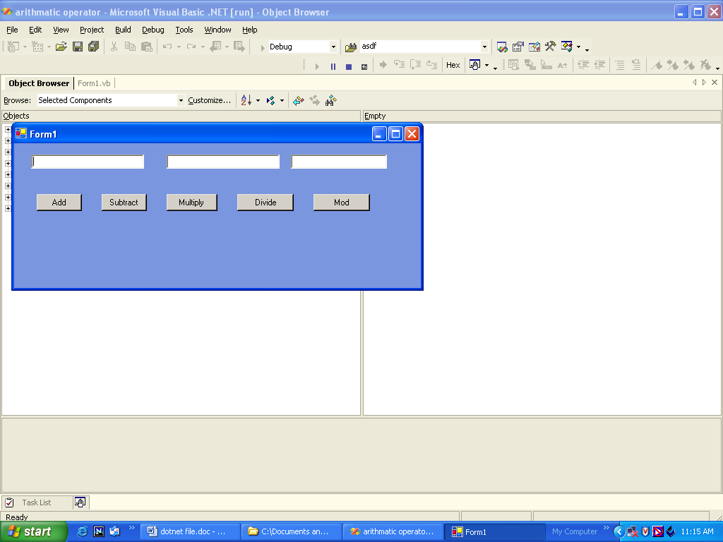

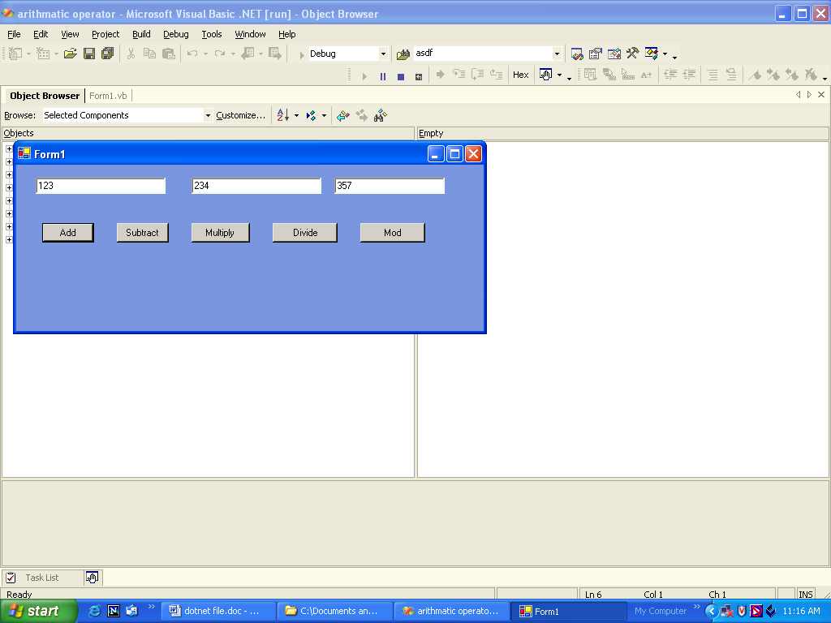

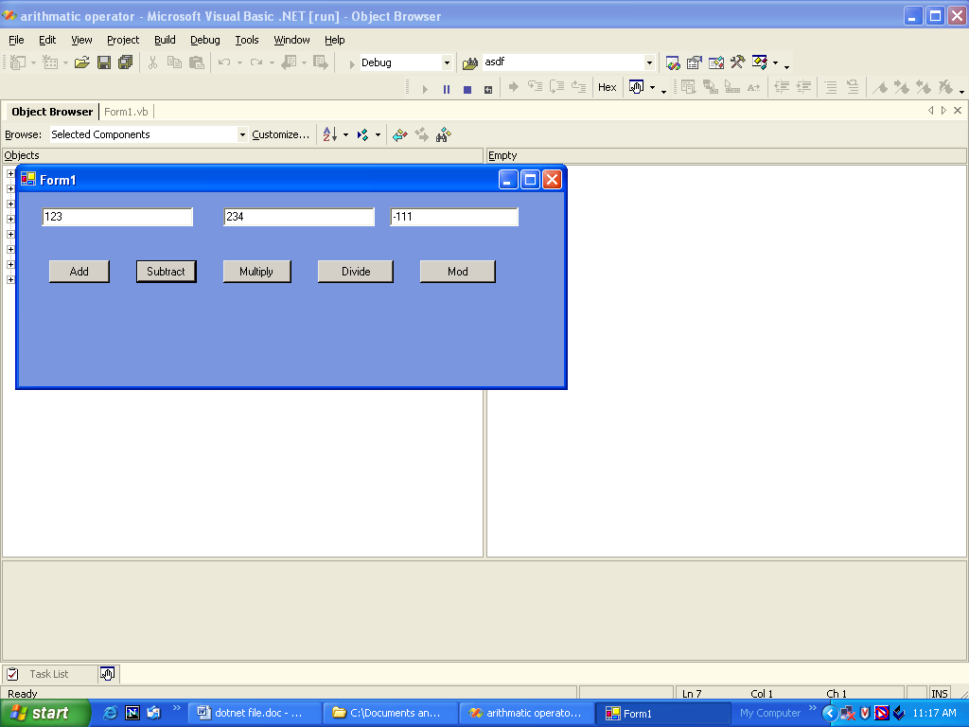

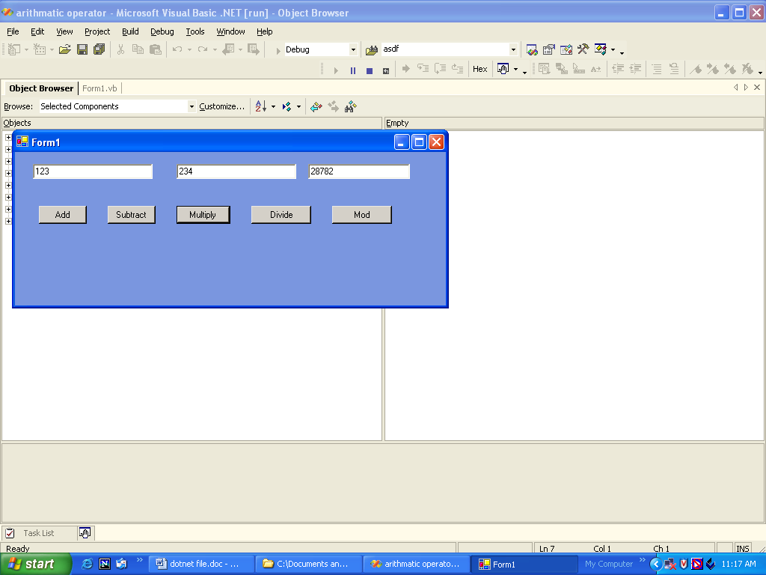

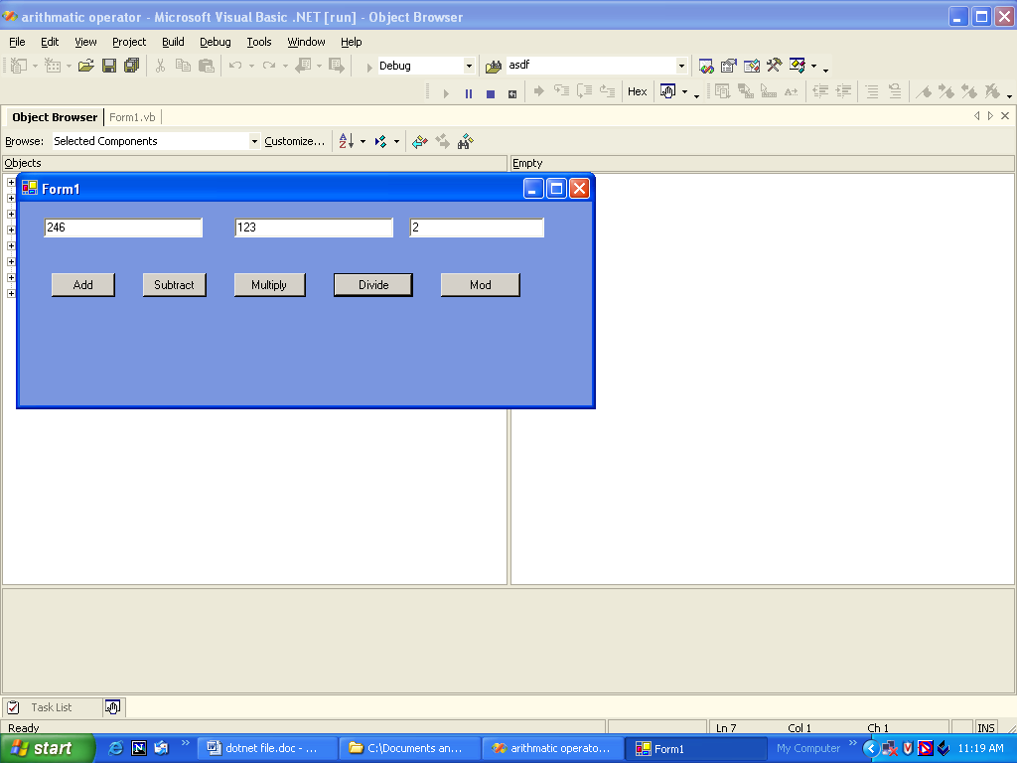

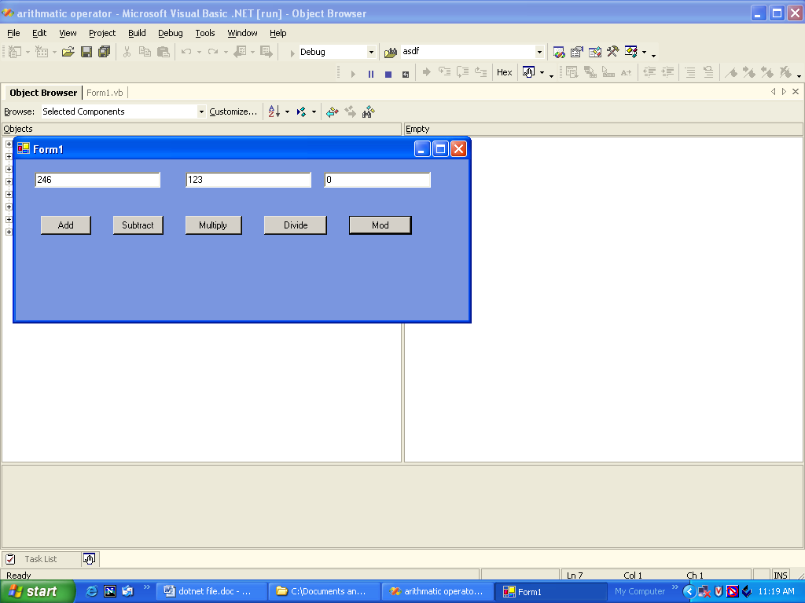

PROGRAM 3:
TITLE : DESIGN A NOTEPAD

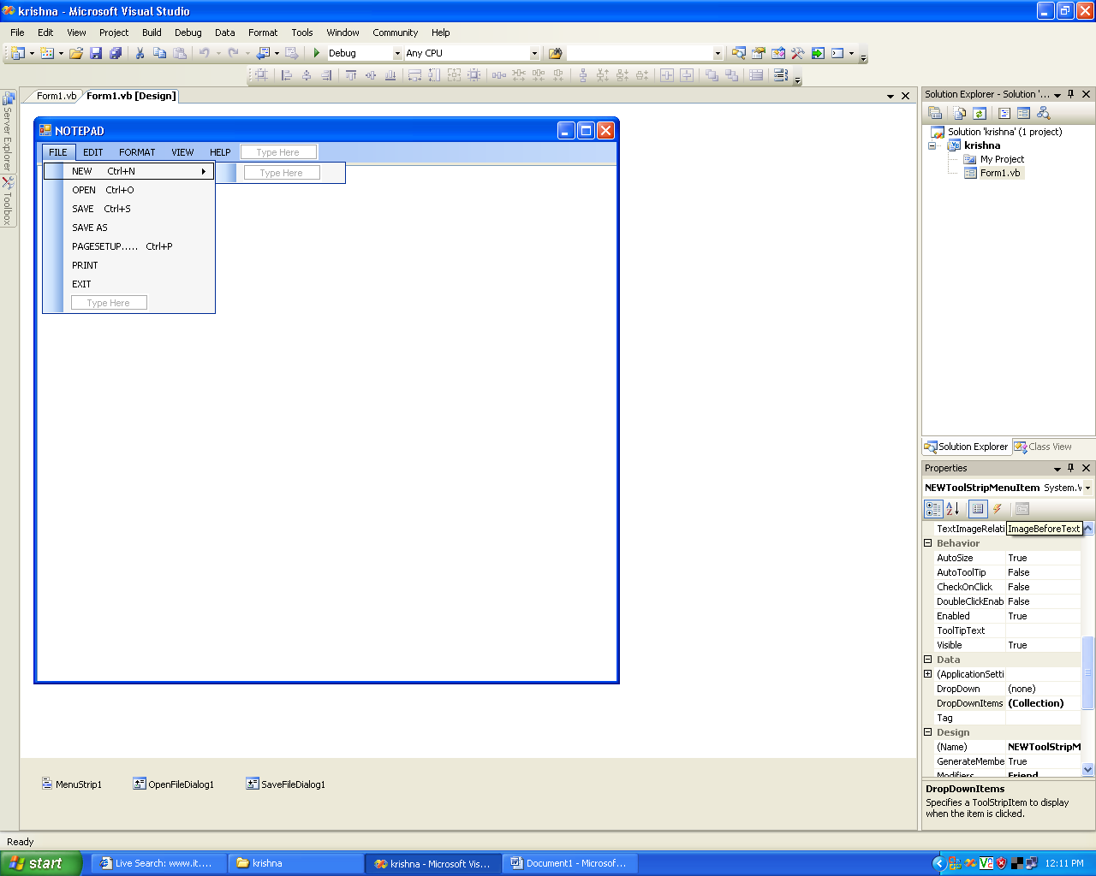

Public Class Form1

Private Sub NEWToolStripMenuItem_Click(ByVal sender As System.Object, ByVal e As System.EventArgs) Handles NEWToolStripMenuItem.Click
TextBox1.Text = ""
End Sub

Private Sub OPENToolStripMenuItem_Click(ByVal sender As System.Object, ByVal e As System.EventArgs) Handles OPENToolStripMenuItem.Click
Dim OFD As New OpenFileDialog
OFD.ShowDialog()
Dim S As String

S = OFD.FileName
Dim F As New IO.FileStream(S, IO.FileMode.Open, IO.FileAccess.ReadWrite)

Dim SR As New IO.StreamReader(F)

TextBox1.Text = SR.ReadToEnd
SR.Close()
F.Close()

End Sub

Private Sub SAVEASToolStripMenuItem_Click(ByVal sender As System.Object, ByVal e As System.EventArgs) Handles SAVEASToolStripMenuItem.Click
Dim sfd As New SaveFileDialog
sfd.ShowDialog()
Dim s As String
s = sfd.FileName
Dim F As New IO.FileStream(s, IO.FileMode.Create, IO.FileAccess.ReadWrite)
Dim sw As New IO.StreamWriter(F)
sw.WriteLine(TextBox1.Text)
sw.Close()
F.Close()

End Sub
End Class

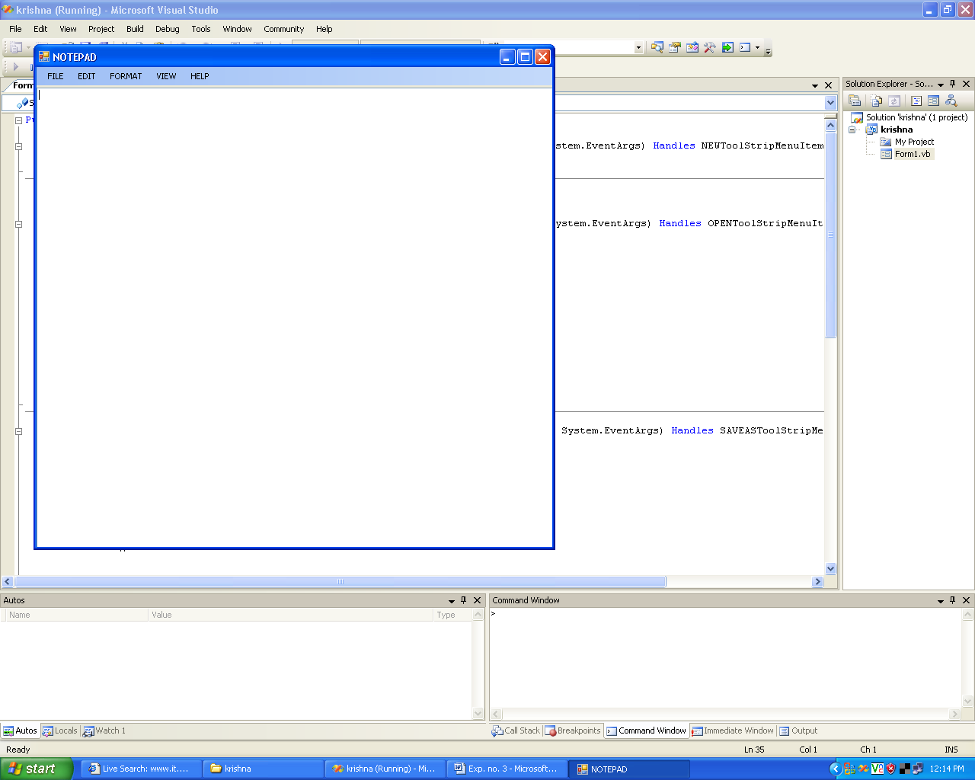

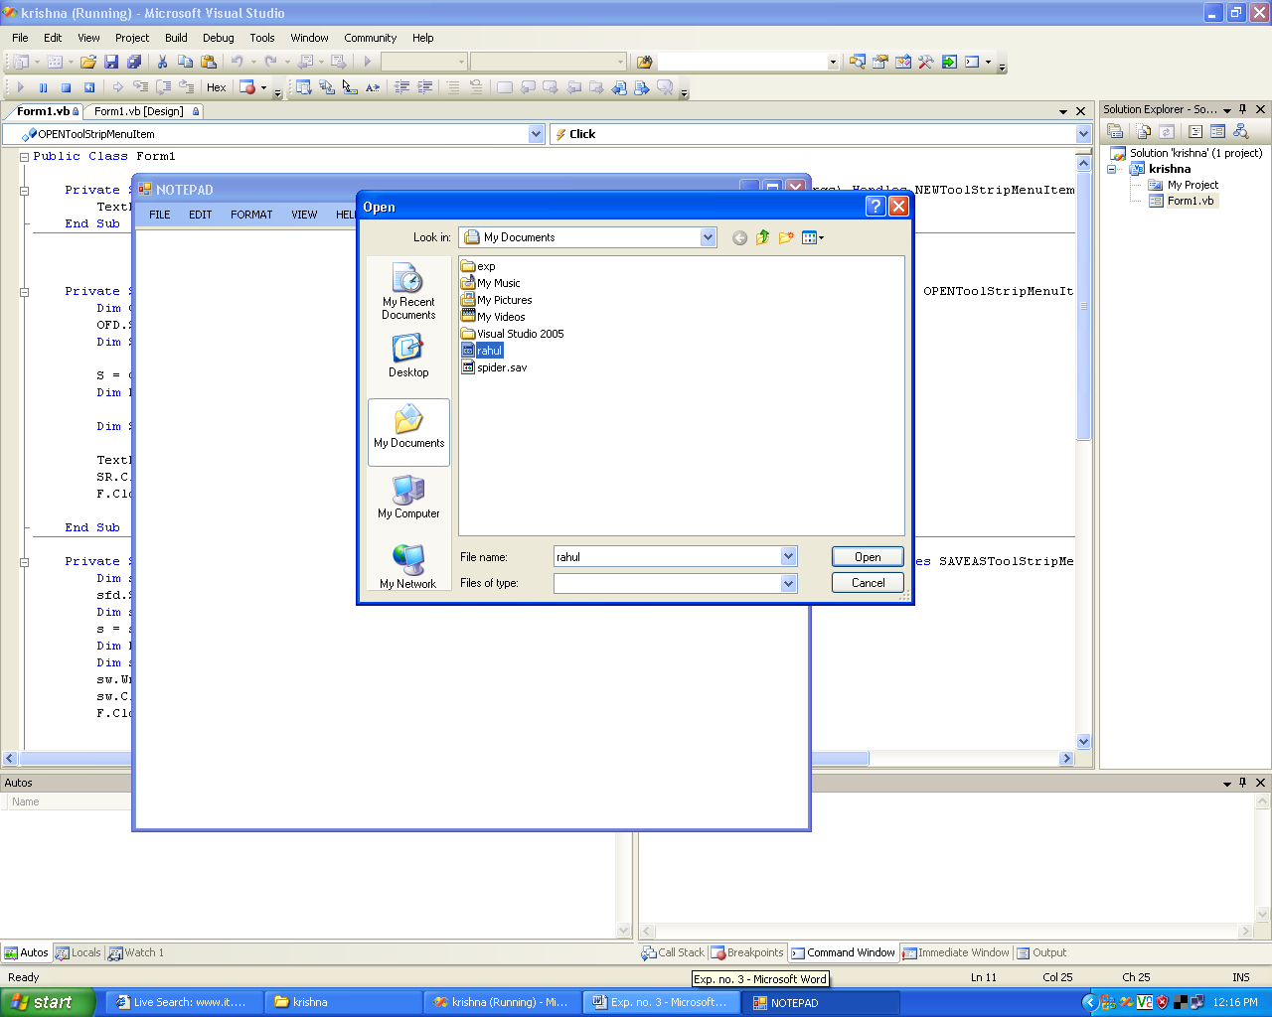

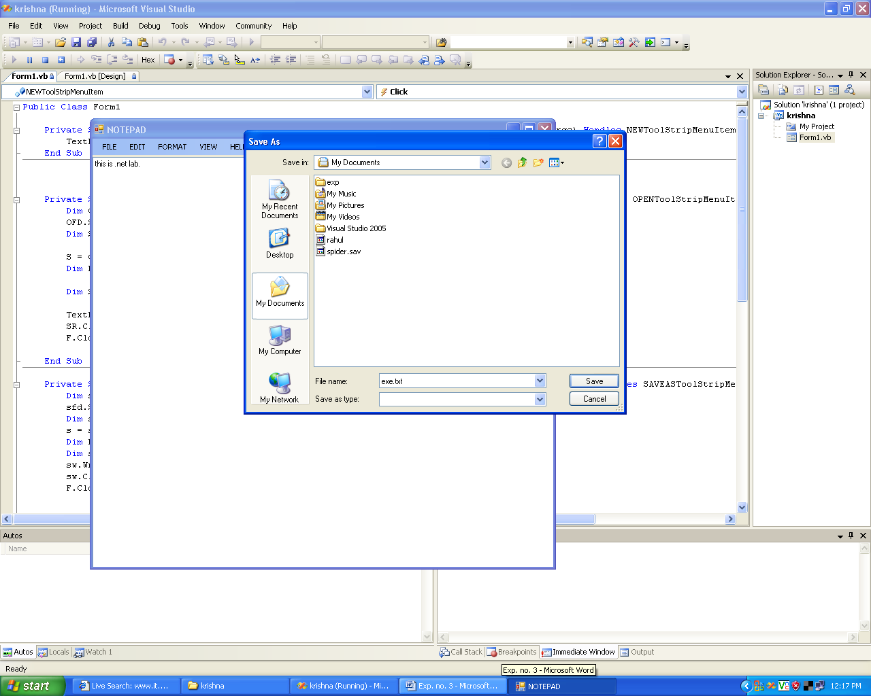

Program: 4

TITLE: Write a program to design a calculator.

Public Class Form1
Inherits System.Windows.Forms.Form
#Region " Windows Form Designer generated code "

Dim zero As Double
Dim one As Double
Dim two As Double
Dim three As Double
Dim four As Double
Dim five As Double
Dim six As Double
Dim seven As Double
Dim eight As Double
Dim nine As Double
Dim plus As Double
Dim save As Double
Dim buttonclick As Double
Dim checked As Double

Private Sub Button10_Click(ByVal sender As System.Object, ByVal e As System.EventArgs) Handles Button10.Click
If checked = 1 Then
TextBox1.Text = 0
checked = 0
Else
Dim read As Double = TextBox1.Text
TextBox1.Text = read & 0
End If
End Sub
Private Sub Button1_Click(ByVal sender As System.Object, ByVal e As System.EventArgs) Handles Button1.Click
If checked = 1 Then
TextBox1.Text = 1
checked = 0
Else
Dim read As Double = TextBox1.Text
TextBox1.Text = read & 1
End If

End Sub

Private Sub Button2_Click(ByVal sender As System.Object, ByVal e As System.EventArgs) Handles Button2.Click
If checked = 1 Then
TextBox1.Text = 2
checked = 0
Else
Dim read As Double = TextBox1.Text
TextBox1.Text = read & 2
End If

End Sub

Private Sub Button3_Click(ByVal sender As System.Object, ByVal e As System.EventArgs) Handles Button3.Click
If checked = 1 Then
TextBox1.Text = 3
checked = 0
Else
Dim read As Double = TextBox1.Text
TextBox1.Text = read & 3
End If

End Sub

Private Sub Button4_Click(ByVal sender As System.Object, ByVal e As System.EventArgs) Handles Button4.Click
If checked = 1 Then
TextBox1.Text = 4
checked = 0
Else
Dim read As Double = TextBox1.Text
TextBox1.Text = read & 4
End If

End Sub

Private Sub Button5_Click(ByVal sender As System.Object, ByVal e As System.EventArgs) Handles Button5.Click
If checked = 1 Then
TextBox1.Text = 5
checked = 0
Else
Dim read As Double = TextBox1.Text
TextBox1.Text = read & 5
End If

End Sub

Private Sub Button6_Click(ByVal sender As System.Object, ByVal e As System.EventArgs) Handles Button6.Click
If checked = 1 Then
TextBox1.Text = 6
checked = 0
Else
Dim read As Double = TextBox1.Text
TextBox1.Text = read & 6
End If

End Sub

Private Sub Button7_Click(ByVal sender As System.Object, ByVal e As System.EventArgs) Handles Button7.Click
If checked = 1 Then
TextBox1.Text = 7
checked = 0
Else
Dim read As Double = TextBox1.Text
TextBox1.Text = read & 7
End If

End Sub

Private Sub Button8_Click(ByVal sender As System.Object, ByVal e As System.EventArgs) Handles Button8.Click
If checked = 1 Then
TextBox1.Text = 8
checked = 0
Else
Dim read As Double = TextBox1.Text
TextBox1.Text = read & 8
End If

End Sub

Private Sub Button9_Click(ByVal sender As System.Object, ByVal e As System.EventArgs) Handles Button9.Click
If checked = 1 Then
TextBox1.Text = 9
checked = 0
Else
Dim read As Double = TextBox1.Text
TextBox1.Text = read & 9
End If
End Sub

Private Sub Button17_Click(ByVal sender As System.Object, ByVal e As System.EventArgs) Handles Button17.Click
If checked = 1 Then
Dim d As Double = "."
TextBox1.Text = "."
checked = 0
Else
Dim read As Double = TextBox1.Text
Dim d As Double = "."
TextBox1.Text = read & "."
End If

End Sub

Private Sub Button13_Click(ByVal sender As System.Object, ByVal e As System.EventArgs) Handles Button13.Click
Dim read As Double = TextBox1.Text
If buttonclick = 89 Then
TextBox1.Text = save + read
checked = 1
save = TextBox1.Text
Else
save = TextBox1.Text
buttonclick = 89
TextBox1.Text = "0"
End If

End Sub

Private Sub Button14_Click(ByVal sender As System.Object, ByVal e As System.EventArgs) Handles Button14.Click
Dim read As Double = TextBox1.Text
If buttonclick = 1 Then
TextBox1.Text = save - read
checked = 1
save = TextBox1.Text
Else
save = TextBox1.Text
buttonclick = 1
TextBox1.Text = "0"
End If

End Sub

Private Sub Button16_Click(ByVal sender As System.Object, ByVal e As System.EventArgs) Handles Button16.Click
Dim read As Double = TextBox1.Text
If buttonclick = 2
TextBox1.Text = save * read
checked = 1
save = TextBox1.Text
Else

save = TextBox1.Text
buttonclick = 3
TextBox1.Text = "0"
End If

End Sub

Private Sub Button11_Click(ByVal sender As System.Object, ByVal e As System.EventArgs) Handles Button11.Click
Dim read As Double = TextBox1.Text
If buttonclick = 89 Then
TextBox1.Text = save + read
checked = 1
buttonclick = 0
save = 0
ElseIf buttonclick = 1 Then
TextBox1.Text = save - read
checked = 1
buttonclick = 0
save = 0
ElseIf buttonclick = 2 Then
TextBox1.Text = save / read
checked = 1
buttonclick = 0
save = 0
ElseIf buttonclick = 3 Then
TextBox1.Text = save * read
checked = 1
buttonclick = 0
save = 0
End If

End Sub

Private Sub Button12_Click(ByVal sender As System.Object, ByVal e As System.EventArgs) Handles Button12.Click
TextBox1.Text = 0
save = 0
checked = 0
buttonclick = 0

End Sub

Private Sub Button18_Click(ByVal sender As System.Object, ByVal e As System.EventArgs) Handles Button18.Click
If TextBox1.Text.Length = 1 Then

TextBox1.Text = 0
Else

Dim value1 As Double = TextBox1.Text.Length - 1
Dim val As Double = TextBox1.Text.Remove(value1, 1)
TextBox1.Text = val
End If
End Sub

End Class

Output:

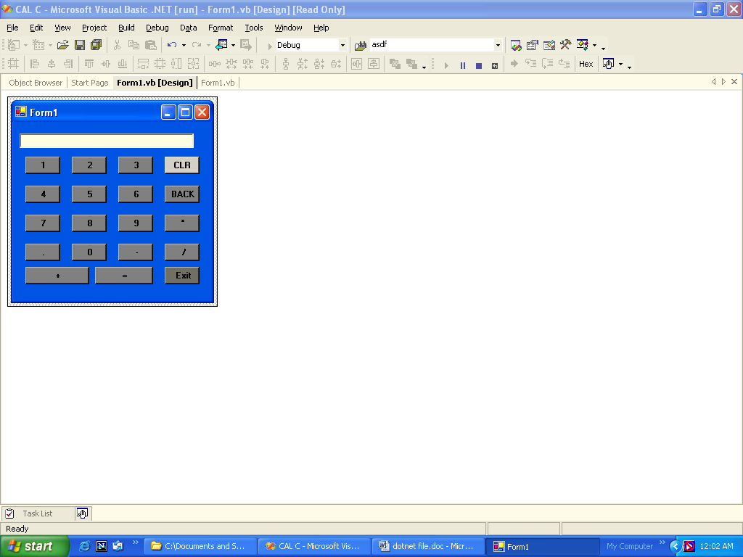

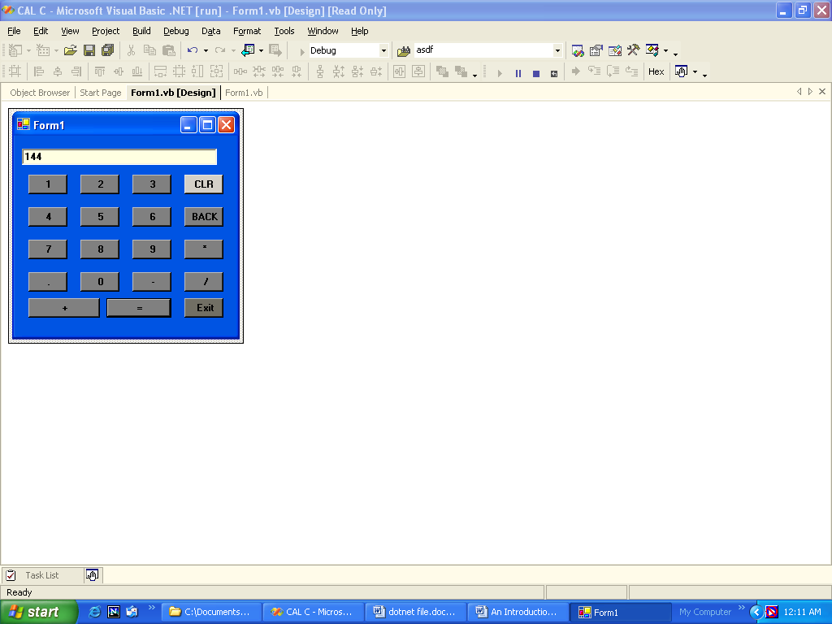

Program:5

TITLE: Write a program to add the 1 to 100 nos.

Public Class Form1
Inherits System.Windows.Forms.Form

Region " Windows Form Designer generated code "

Private Sub Button1_Click(ByVal sender As System.Object, ByVal e As System.EventArgs) Handles Button1.Click
Dim intcounter, intsum As Integer
intcounter = 0
intsum = 0
Do
intcounter = intcounter + 1
intsum = intsum + intcounter
Loop Until (intcounter = 100)
Debug.WriteLine("THE SUM OF 100 NUMBERS:" & intsum)
Label1.Text = "THE SUM OF FIRST 100 NUMBERS:" & intsum
End Sub

Private Sub Button2_Click(ByVal sender As System.Object, ByVal e As System.EventArgs) Handles Button2.Click
End
End Sub
End Class

Output:

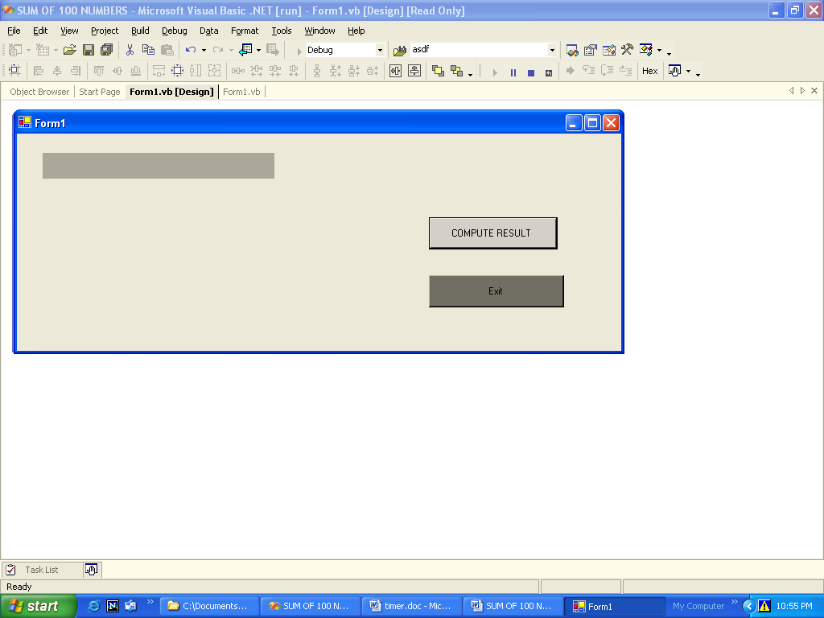

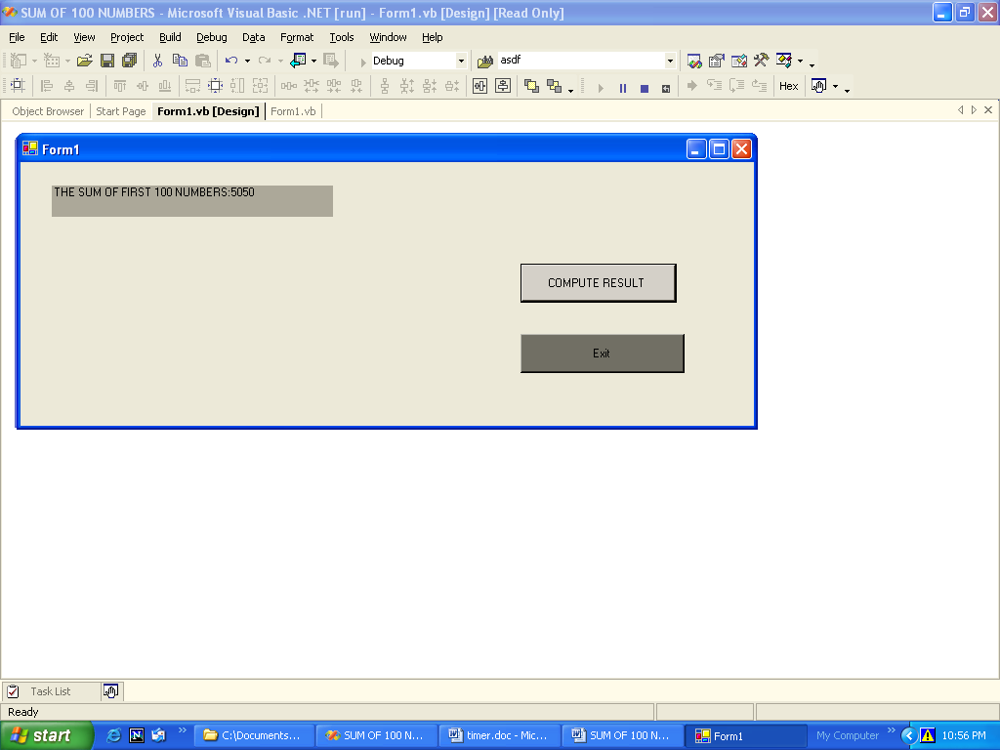

Program:6

TITLE: Write a program to change the options using msgbox function.

Public Class Form1
Inherits System.Windows.Forms.Form

#Region " Windows Form Designer generated code "

Private Sub Button1_Click(ByVal sender As System.Object, ByVal e As System.EventArgs) Handles Button1.Click
MsgBox("Do you want to eat something?", 35, "Eating Zone")
End Sub

Private Sub Button2_Click(ByVal sender As System.Object, ByVal e As System.EventArgs) Handles Button2.Click

MsgBox("Do you want to eat?", MsgBoxStyle.YesNo, "Reply")
MsgBox("Food not available!", 53, "What to do?")
End Sub

Private Sub Button3_Click(ByVal sender As System.Object, ByVal e As System.EventArgs) Handles Button3.Click
MsgBox("Do you want to drink?", 64, "Reply")
MsgBox("Drinks are on cash payment only!", 53, "What to do?")
End Sub
End Class

Output:

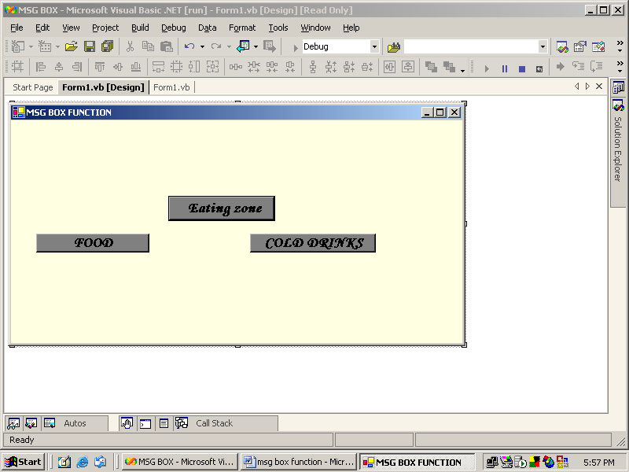

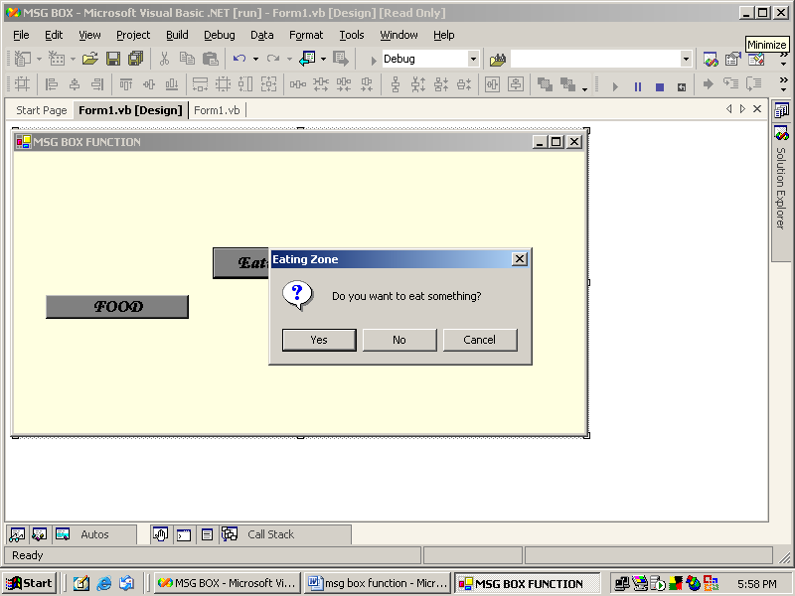

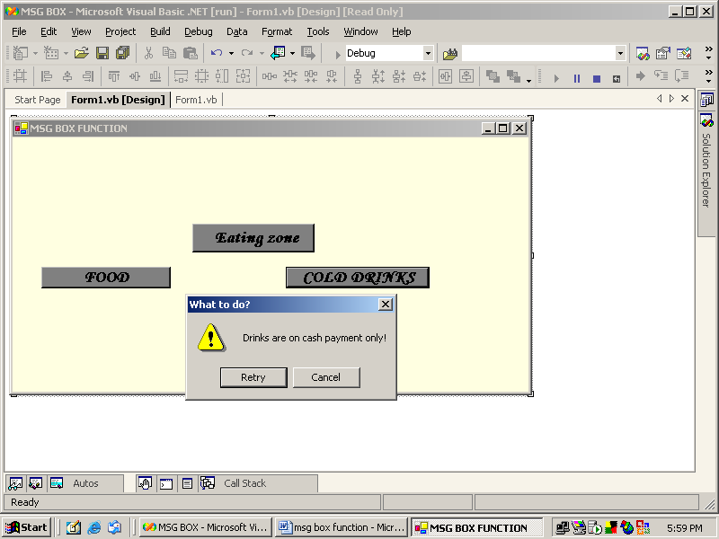

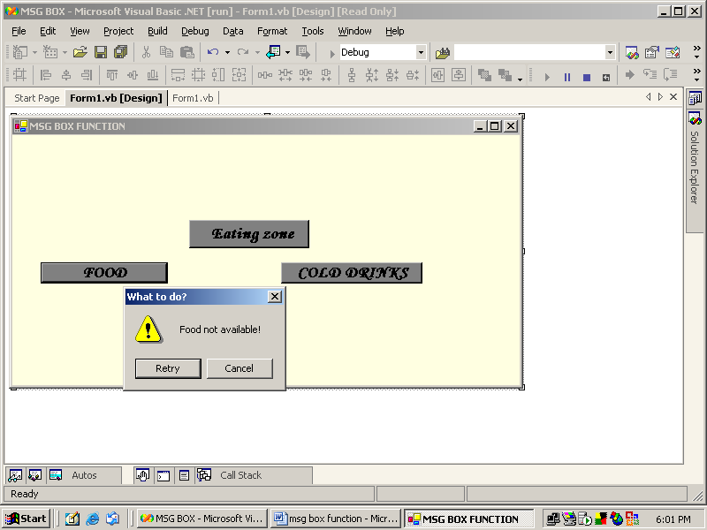

Program: 7

TITLE: Write a program on vertical & horizontal scrollbar control.

Public Class Form1
Inherits System.Windows.Forms.Form

Region " Windows Form Designer generated code "

Private Sub VScrollBar1_Scroll(ByVal sender As System.Object, ByVal e As System.Windows.Forms.ScrollEventArgs) Handles VScrollBar1.Scroll
lbl.Height = VScrollBar1.Value
lbl.Text = "value of the vertical scrollbar=" & VScrollBar1.Value
End Sub

Private Sub HScrollBar1_Scroll(ByVal sender As System.Object, ByVal e As System.Windows.Forms.ScrollEventArgs) Handles HScrollBar1.Scroll
lbl1.Width = HScrollBar1.Value
lbl1.Text = "value of the Horizontal scrollbar=" & HScrollBar1.Value

End Sub

Private Sub Button1_Click(ByVal sender As System.Object, ByVal e As System.EventArgs) Handles Button1.Click
End
End Sub
End Class

Output:

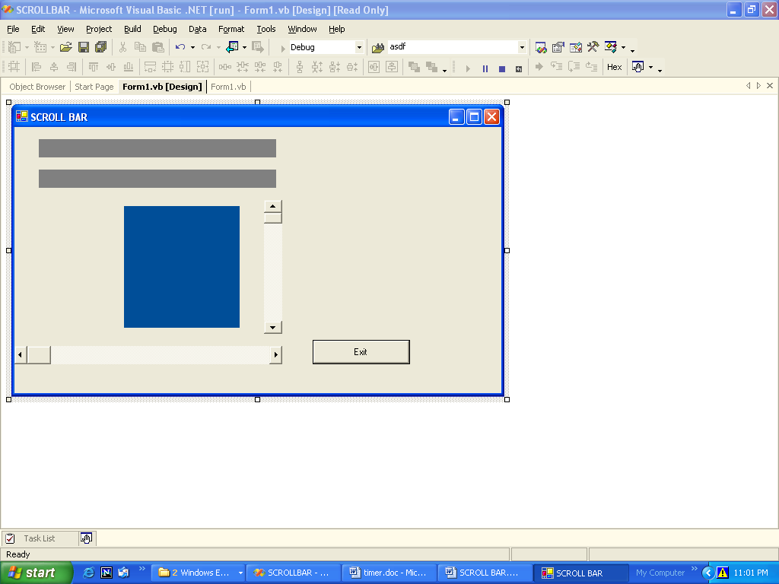

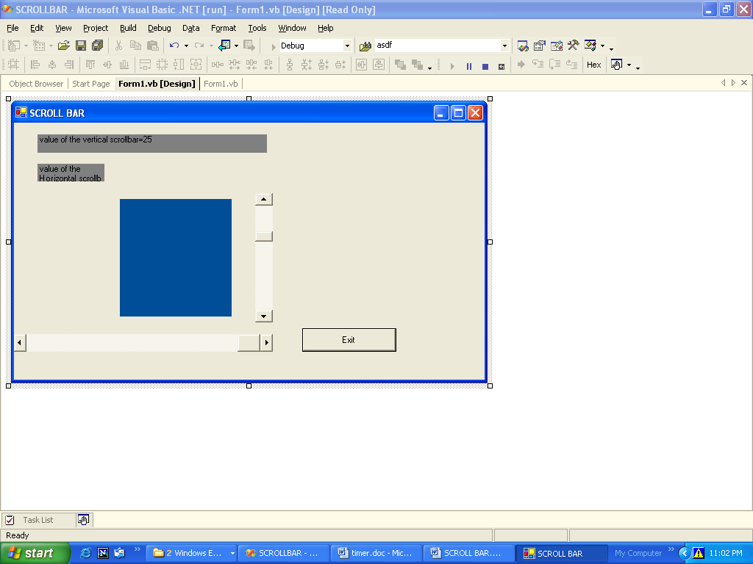

Program: 8

TITLE: Write a program to change the color of background of window using radio buttons.

Public Class Form1
Inherits System.Windows.Forms.Form

Windows Form Designer generated code

Private Sub Button2_Click(ByVal sender As System.Object, ByVal e As System.EventArgs) Handles Button2.Click
ActiveForm.BackColor=System.Drawing.Color.Green

End Sub

Private Sub Button3_Click(ByVal sender As System.Object, ByVal e As System.EventArgs) Handles Button3.Click
ActiveForm.BackColor =System.Drawing.Color.Blue
End Sub

Private Sub Button4_Click(ByVal sender As System.Object, ByVal e As System.EventArgs) Handles Button4.Click
ActiveForm.BackColor = System.Drawing.Color.Red
End Sub

Private Sub Button5_Click(ByVal sender As System.Object, ByVal e As System.EventArgs) Handles Button5.Click
ActiveForm.BackColor = System.Drawing.SystemColors.Control
End Sub

Private Sub Button1_Click(ByVal sender As System.Object, ByVal e As System.EventArgs) Handles Button1.Click
End

End Sub
End Class

Output:



